Senior Infant work Class teacher: Niamh Waldron
Dear Parents,
Hope you are all keeping well and enjoying the beautiful sunshine. Super work being done at home. Well done to everyone.
This week there is a nice sequencing activity attached to Mr Cuddles letter.
Plenty of Wordsearch Handouts based on high frequency words which seem to be a favourite with the Senior infant kids. Lots of maths handouts for revision. Nice handouts in irish for revision on topics covered throughout the year. Many of the kids will be finishing up workbooks now and also the *I can read booklet that we have been working on. There is a Checklist on the school website for 100 highest frequency words-very useful tool to see where your child is at in reading.
Keep up all the great work at home.
Niamh Waldron
June (2nd-5th) (8th-12th)
English
Phonics /Word building  Booklet I can read booklet- (keep working on this booklet and even making sentences with words would be very beneficial for the children ) |  | New Digraph booklet  (Keep working on this workbook) |  | Sounds Make words  Pg 71  Pg 74  Pg 78  Pg 79 & 80
Reading  Shared reading  Oxford reading tree  Big cat readers  Epic readers  (shared readers available online- see note on website re logging onto sites)  ***Checklist on school website 100 highest frequency words- beneficial to check your childs reading level |  | Handouts  - Sequencing activities based on story The Zoo Vet.  - Wordsearches for high frequency words  - I spy & checklist |  | - Mr Cuddles letters  - Story: The Zoo vet  - Poem Summer
Handwriting  - All write Now (home school book)  This workbook should now be completed  - All write now pupil book  Keep working on this workbook now. |  | Writing activity  - What can you see at the beach?  - Write 5 sentences about Summer.  - Keep a daily diary write a few sentences about your day.
Practical maths  * Making simple sums to 10 using everyday objects at home  eg Use pieces of lego,  or whatever is handy  Placing 10 objects in a row kids partition the 10 using a pencil or lollipop stick into two groups and then writing the sum.  Eg  5+5=10  6+4=10  3+7=10  8+2=10  and then they can try with three groups  3+4+3=10  6+2+2=10  7+2+1=10 | Counting  Counting forward and backwards to and from 26 from different staring points  - Counting in 2s to 12  - Counting in 10s to 50  - Practice Writing number words  one to seven |  | - Busy at maths Assessment Booklet – (complete booklet -good for revision) |  | Handouts  - All about 11  - All about 13  - Block graph on Food  - Block graph on weather  - Months of the year

Gaeilge
- Bua na cainte  *Theme -An teilifis  (this is a new theme)  Pg 41-46  *Theme- Siopadóireacht  (This is a new theme)  Pg 47-51 | Cluichí (Games)  - Feicim le mo shúilín bheag  Na baill chorpa (the body parts) Feicim le mo shúilín bheag  Sa Zú | Cluichí  - Is maith liom/Ní maith liom  *Bia  *Deochanna  (drinks) | - Please note the pupils book Bua na cainte has great phrases at end of each page. It is also  available online too.

PE
Rte junior 10@10  - Episode 9  - Episode 10 | - PE with Joe  The body coach daily lessons to check out

Science History Geography
Small world workbook  - Healthy Food- pg 51  - Exercise is good for you- pg 52  - What’s for dinner-pg 57 | Small world workbook  - What happens next?-pg53 | Small world workbook  - Serengeti Safari pg 54/55  - Ireland or far away  Pg 56
Summer 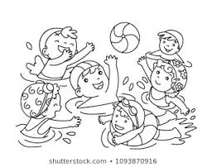
Summer, Summer
Time for fun.
We run all day in the hot, hot sun.

Summer, Summer
Jump in the pool.
Eat a lot of icecream
To keep cool.
Write 5 sentences about Summer
I like Summer because……………
In Summer ………….
Sometimes I ……………

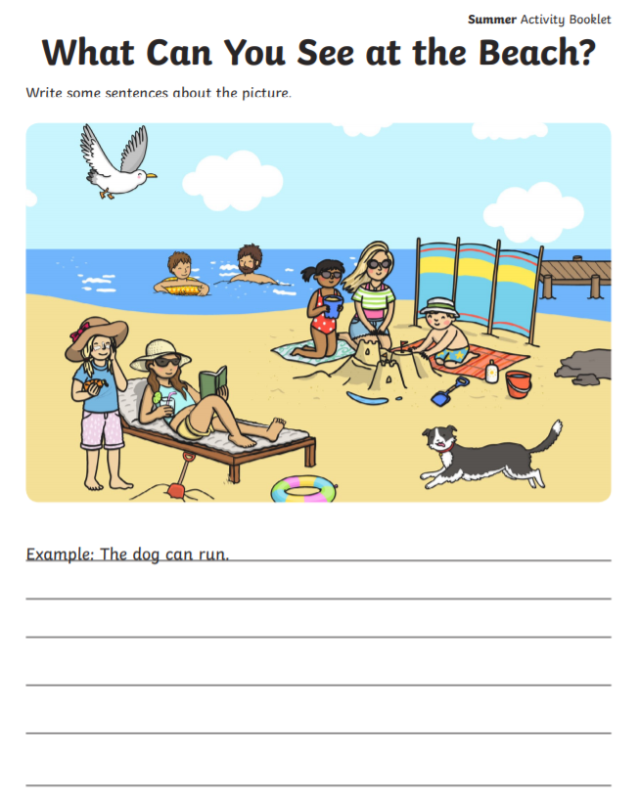
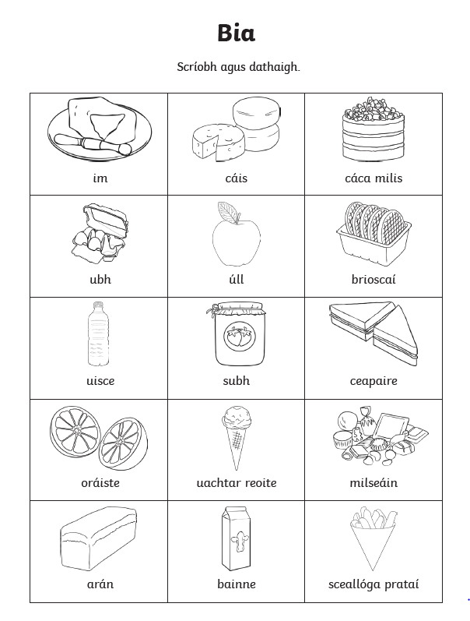
Encourage your child to say the word and then colour the picture. Encourage your child to make simple sentences orally using the above words.
eg Is maith liom uachtar reoite.
Ní maith liom im.
Is maith liom bainne.
Ní maith liom sceallóga prátaí.
Is maith liom_________________ Ní maith liom_________________
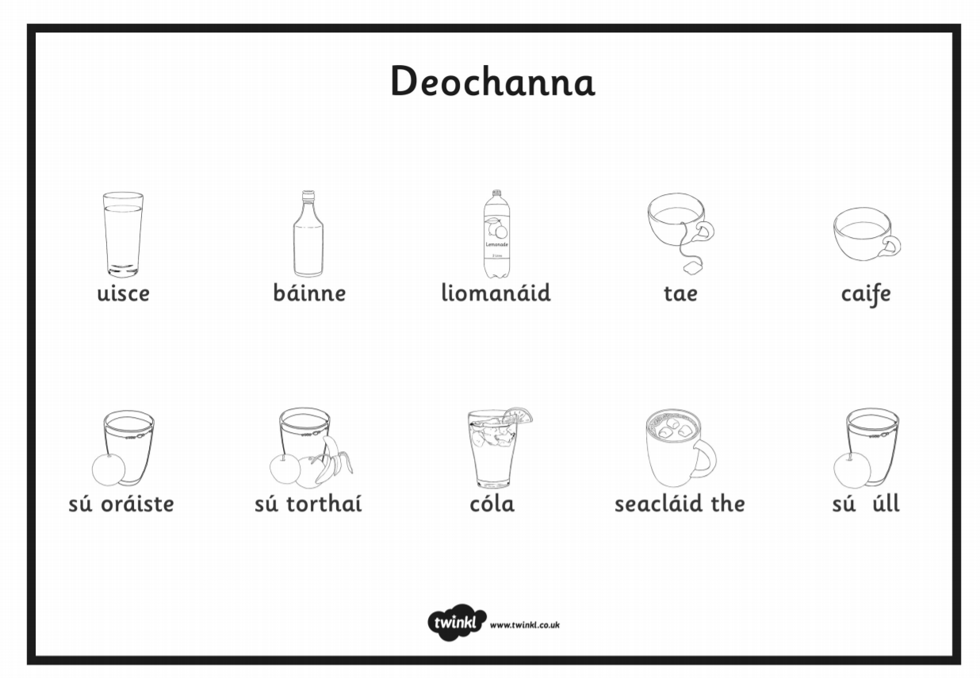

Uisce (water) sú (juice) sú úll (apple juice) sú oráiste (orange juice) sú torthaí (fruit juice) tae (tea) caife (coffee) seacláid the (hot chocolate) líomanáid (lemonade)
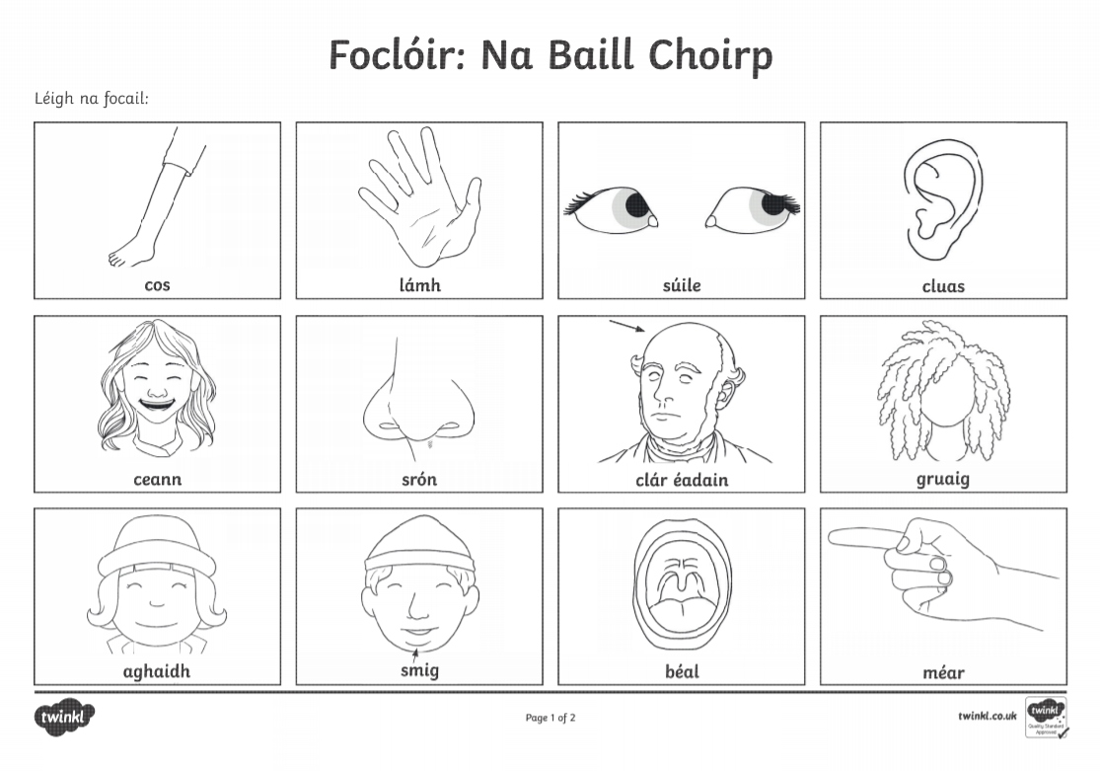
This activity can be used to play the game: Feicim le mo shúilín bheag
Eg
- Feicim le mo shúilín bheag rud a thosaíonn le c
cos, ceann, cluas, clár éadain
- Feicim le mo shúilín bheag rud a thosaíonn le b
béal,
- Feicim le mo shúilín bheag rud a thosaíonn le s
smig, súile, srón
- Feicim le mo shúilín bheag rud a thosaíonn le a
aghaidh
- Feicim le mo shúilín bheag rud a thosaíonn le g
gruaig,
- Feicim le mo shúilín bheag rud a thosaíonn le m
méar
- Feicim le mo shúilín bheag rud a thosaíonn le l
lámh

