Programme of Work - Sixth Class
Monday June 8th to Friday June 12th.
Work can be uploaded to our email or Google classroom.
http://www.scoilanspioraidnaoimhrox.ie/
Google classroom - code c3lrwn7.
( Parental permission needed to sign in)

Maths:
( Answers will be put up on the school website at the end of the week).
- Brain Teasers - complete two tests daily ( You should be on test 95).
- Mathemagic 6 - Chapter 49 - Chance - Pages 165-170
- Chance or probability in mathematics is about
  - The identification or listing of all possible outcomes
  - estimating the likelihood of occurrence of certain events

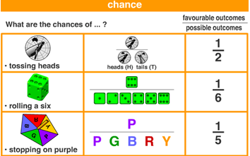
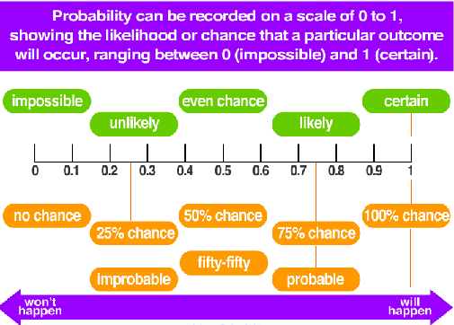
- If you toss a coin the likelihood of getting a head is
  - 1 in 2 or $\frac{1}{2}$ or 50%
- If you roll a six sided dice the chances of getting a six is
  - 1 in 6 or $\frac{1}{6}$ or 16.66%
- Questions 1 and 2 on page 165 can be done orally
- Write the answers to Q. 3 page 165 and Q 1-5 page 166
- Complete Q. 1 Page 167 and Q. 1, 2, and 3 page 168 in your maths copy.
- Complete Q.2 and 3 Page 169 in your copy
- Complete Q.1-5 Page 170 in your maths copy.

Gaeilge:
(We will put up sample answers on Google Classroom on Friday)
Sin É 6:
- Briathar Neamhrialta - Abair -page 185. Scríobh na habairtí i gceart P. 185
Mo Scór! 6
- Cuir an sliocht san aimsir láithreach - Page 30
- Cuir an sliocht san aimsir fháistineach - Page 30
Bun Go Barr 6
- Foghlaim agus críochnaigh na habairtí - page 122
- Líon na bearnaí - Lá Faoin Tuath - Page 123

Please watch Cúla4 on TG 4 at 10.00 – 10.25 each morning. The spoken Irish in this programme is excellent. You won’t understand everything but don’t worry.

English:

- Spelling: Spellbound 6 : Week 33 - Revision. Complete exercises 1-5 pages 68-69.
- Reader : By the North Star: Unit 38 - Unfortunate Conclusions - Pages 172 - 175.
  - Complete the purple activity P.176
  - Complete the blue and red activities - P.177
- Cloze activity: On the Food Front - Food in Britain during the Second World War ( on the school website)
- Grammar exercise - Adjectives ( on the school website)
- Complete exercises A and B
  - An adjective tells us more about a noun or pronoun
  - A positive adjective describes one item
    - e.g. the tall lady
  - A comparative adjective compared two items
    - e.g. My brother is taller than I am
  - A superlative adjective compares several items
    - the tallest building in the world is in Dubai
5. Read the passage Are Zoos Ethically Wrong ( on the school website). Write a paragraph giving your opinions on zoos.

Epic the on line reading app is free to access at home if parents send a request to us at roxpupils.ias@eircom.net.
Further reading material is available through the primary planet magazine at www.theprimaryplanet.ie – lots of tips and hints , recipes, crosswords etc.

Geography:
Small World: Geography and Science.
Unit 18 : Weather and Climate
- Read pages 99 to 103.
- Select one of the following and complete a short presentation on it
- Weather instruments
- Met Eireann and weather forecasts
- Factors influencing climate

History: ( continue working on your transport presentation)
Design a presentation on the topic - Transport Through the Ages.

Science:
The Burren
- Read through the Powerpoint presentation on the school website
- please complete a one page project on one of the following
  - Flora and Fauna in the Burren
  - Limestone caves in the Burren

Music:
Try playing some of the following tunes:
Shallow
Thank You for the Music
Art:
- Design a sports kit ( see template on the school website). (You can log into
oneill’s.ie and design it there.
- Design a Water Safety Poster for younger kids suitable to upload to the school website ( over two weeks). Lots of ideas on the Teachpaws.ie website.
Or
As Monday June 8th is World Oceans Day create a poster to highlight the problem with plastic in the ocean. ( Ideas in National Geographic for Kids)
PE
Try to get 60 minutes throughout the day.
Here are some suggestions for the coming week.
- FAI Home Skills –check their web site.
- Walk , run or cycle- make sure it is safe.
- PE with Joe Wicks
- Tennis
- Skipping
- Elastics
- Activity Circuits- easily made with chalk
- Basketball shooting practice- free throws and lay up shots
- Dance to music- go noodle, etc. creative dance.
- http://www.irelandsfittestperson.com/ (optional)
- Cúla 4 ar scoil have lots of activities.
- Balloon Volley ball
- Run around Ireland challenge- chart and map on the website.
- Scoil net have “Beyond the classroom” activities to develop fundamental movement skills.

