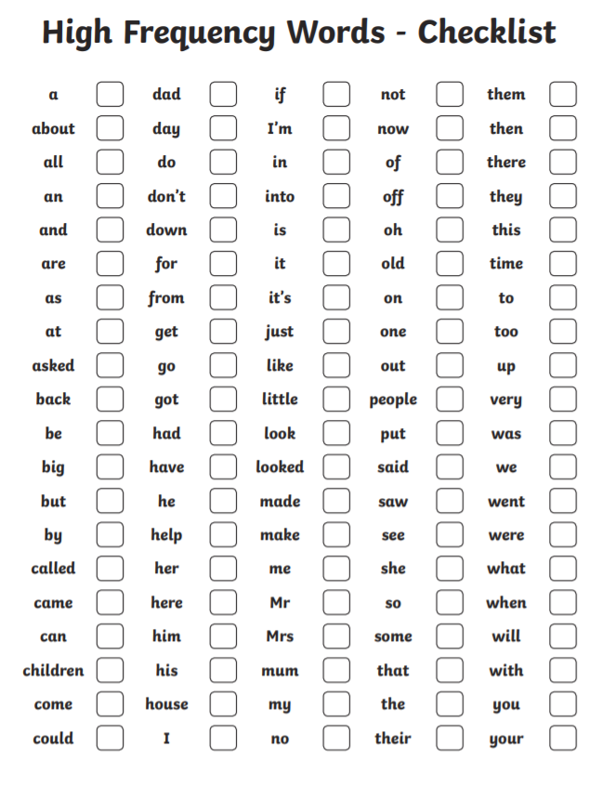

Dear Parents,
This is a useful checklist to use at home with your child to monitor how your child is doing at reading. It is useful for checking the first 100 high frequency words. Put a tick when your child reads the word. Leave blank if they don’t know the word. It is scored out of 100.

