- Some poetry to inspire creativity and imagination….[poetry and art time]
- Your child might say the poems out loud…do the actions and draw some pictures.
- Can you label the pictures using the highlighted words?

Undersea by Marchette Chute
Beneath the waters
Green and cool
The mermaids keep
A swimming pool.

The oysters trot;
The lobsters prance;
The dolphins come
To join the dance

But the jellyfish
Who are rather small
Can’t seem to learn
The steps at all.

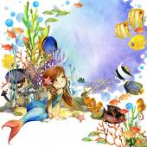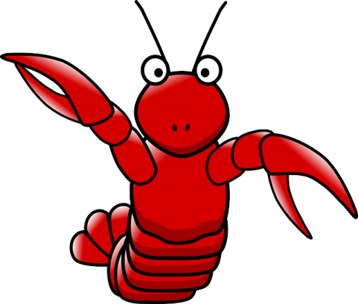

_______________ ____________________

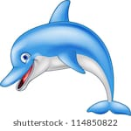

__________________

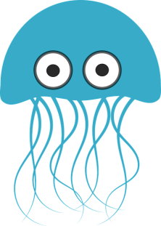
_________________
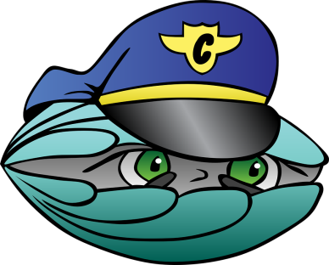_____________
- colour and cut out the dolphins and stick to a blue background
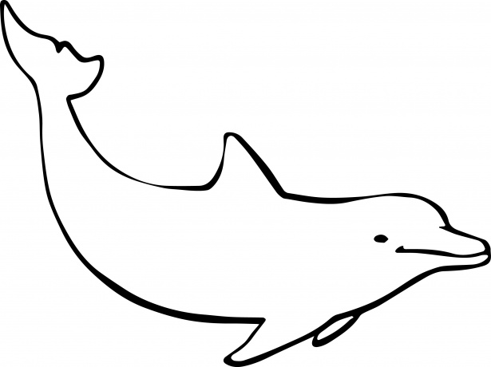

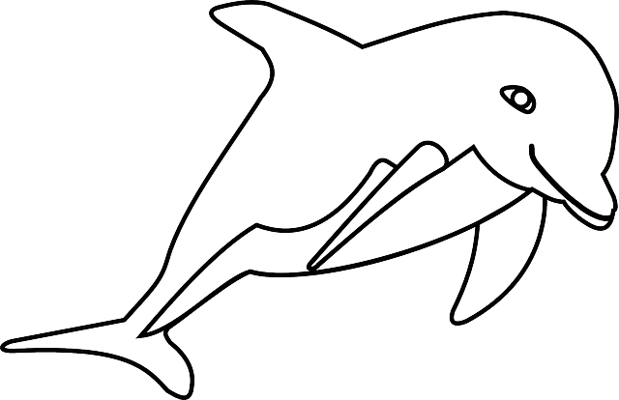
- colour the undersea picture

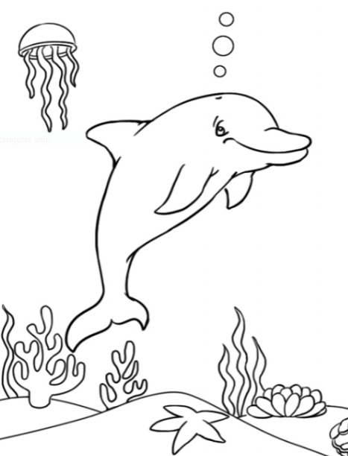

- the rainbow fish and a starfish to colour and cut out [maybe]
- play the story of “The Rainbow Fish” by Marcus Pfister on YouTube.

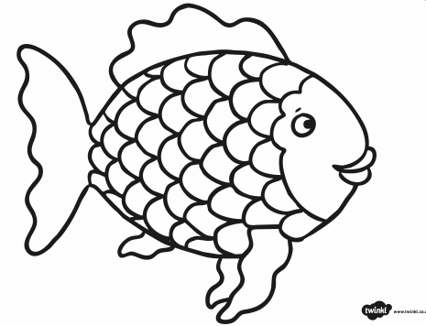

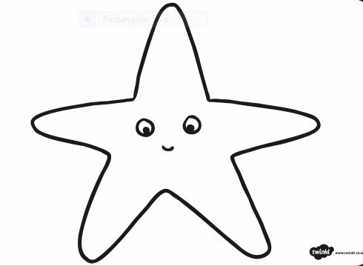
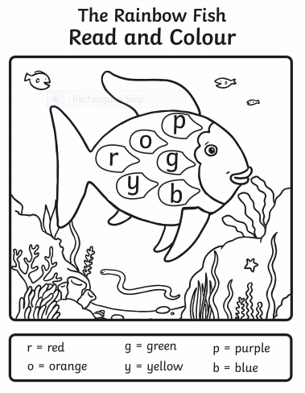

- Listen to the story on YouTube and colour
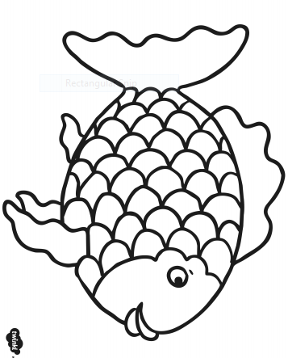

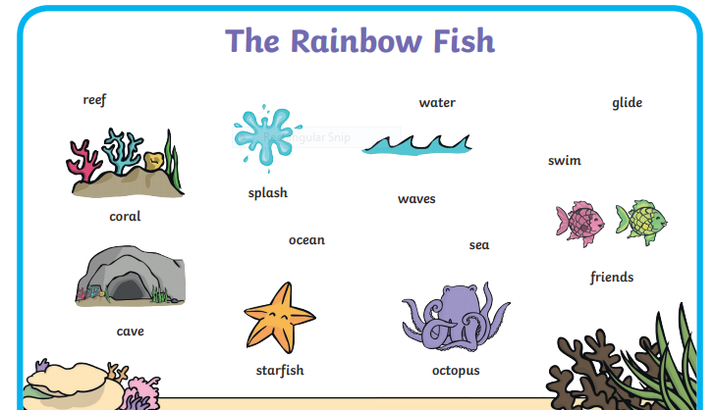

- Practise saying these words

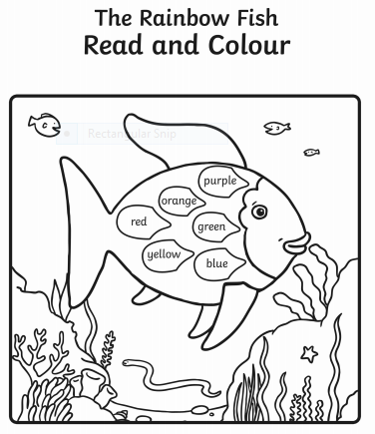
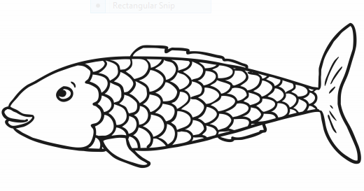

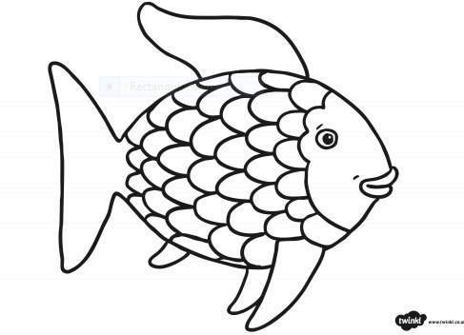

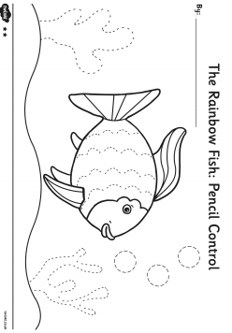

- poem/song [the children are familiar with this song]

I am a terrible tiger
with terrible tiger’s claws.
I’ll lie down here and go to sleep,
my head between my paws.
We’re looking for the terrible tiger.
We’re on that tiger’s trail,
and when we find that tiger,
we’ll pull that tiger’s tail

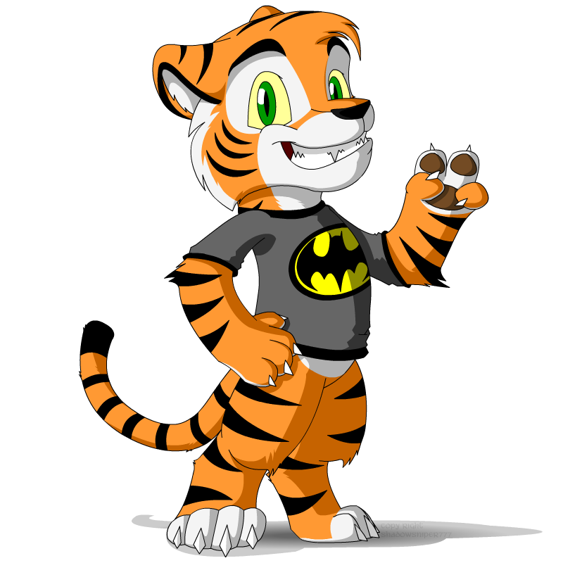

Draw your own tiger.

- Pressed flower art……
Flowers are growing eveywhere now that the weather is warmer,so it’s a good time to make a pressed-flower card for someone special.

Instructions;
1.Collect a variety of flowers ,including their stems.
2.Observe how they look now.
3.Place them inside a heavey book to flatten them.
4.Leave them for a few days,then gently peel them off the pages.
5.Glue them to a blank card to make a beautiful surprise for someone special.

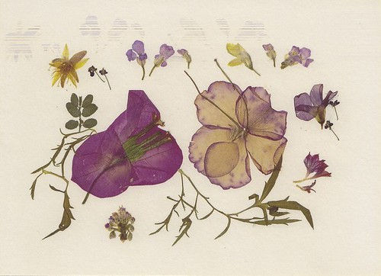

- Let’s make art prints using bubbles!
What you will need…..
- water-based paint…different colours
- a jar of water
- washing-up liquid
- paint pots/small cartons
- a shallow tray
- straws
- white paper

Instructions:
- Mix together equal amounts paint, water and washing-up liquid in a small pot/carton.
- Pour into a shallow tray.
- Take a straw, place into the liquid and gently begin to blow [making sure not to suck or you’ll end up with a mouthful of paint!]
- Move the straw around, creating bubbles.
- Once the tray is full of bubbles, take a sheet of paper and lay it carefully on top of the tray, pressing down gently.
- Carefully lift the paper off to see the print the bubbles have created.

