Senior Infant work Class teacher: Niamh Waldron
Dear Parents
I hope you are all keeping safe and well and enjoying the nice weather. This fortnight I put up plan of work and lots more activities that can you can download from the school website. New things to look out for a game I spy in Irish and a new digraph booklet to print (available on school website).

Please note
Folens is available online and you can access our Starlight Reading Scheme. Many of you now have being using this already. Password is on school website. We are moving onto a new unit15 Theme Holidays.
April (20th-24th) (April 27th- May 1st)
English
Phonics /Word building | Just Phonics | New Digraph booklet  Available to download from school website. (This is very much at the children’s wordbuilding level.) | Sounds make words  Pg 50 middle sounds ee/ai  Pg53 cross word  Pg 56  Pg 60- ou  Pg 69 -or
Reading  Shared reading  Oxford reading tree online | Folens Starlight scheme:  Unit:15  Theme: Holidays  Reader: A ride at the funfair pg 31-42  Please note Folens is available online we are using Starlight scheme senior infants Unit 15 | Wordlist: unit 15  A ride at the funfair available to download on Folens website  Elf Learning tricky words  Phase 1/ 2/ 3/4  (Keep moving up different levels) | - Mr Cuddles Letters  Story  - Dear Zoo | Folens Starlight scheme  Unit 15  Theme: Holidays  Big book  - All the fun of the fair
Writing  - Handout Escaped zoo animal poster  - Animal fact file (in zoo letter) | Shopping list  Make a list of food items your family needs to buy  Write a letter to Mr Cuddles | - Starlight skills Book  Pg 55-58 | All write now home school book  Pg 28-H  Pg 29-A  Pg 30-U  Pg31-S  Pg 32-z

Oral Language | Poster: The fairground  Unit 15  available online  lots of lovely activities  - Story mode  - Question mode  - Label mode  - Activity mode | available online  lots of lovely activities  Unit 15  Theme Holidays | Poems  - April  - This is the sun  - Ice-cream

Maths
Practical maths  Use containers of different sizes to see which holds more or which holds less  Mathematical language  Holds more holds less, more than, less than,  Most, least  not as much as etc | Busy at Maths  Pg 77/78/79  Topic:Spatial awareness  Pg 116  Pg 117  Pg 118  Topic: Capacity | Counting  Counting forward and backwards to and from 20 from different staring points  - Counting by 2s as far as 10  Video kids tv 123  - Maths rhyme  Two four six eight  (With poems) | Mental maths  (children need lots of practice)  *Adding 4 to a given number to totals of 10  Eg  1+4=  3+4=  *Adding 5 to a given number to totals of 10  Eg  2+5=  1+5= | Handouts  - Number bonds challenges 1& 2  - Capacity  - One more one less  - Spring themed Dot to dot  - More dot to dot activities on school website

Gaeilge
Bua na cainte  Revise  Theme  An scoil  Lth 7-11  Revise  theme Bia lth 12-16 | Cluiche /Game  - Feicim le mo shúilín (on school website) | Please note for revision the pupils book Bua na cainte has great phrases at end of each page. It is also  available online too.

PE
Rte junior 10@10  Episode 4 | Go noodle  Monster moves | PE with Joe  The body coach tv lots of lovely lessons to check out | Endless opportunities  Obstacle courses, hopscotch skipping, football  You can tell me all about them

Science
Videos  - virtual tours of Dublin zoo  - Dublin zoo Easter eggs extravaganza  - Dublin zoo Birdwatching | Letter re Dublin zoo animal encyclopedia  Focus: Zebras and chimpanzee  Zebra Quiz  Chimpanzee Quiz | - Handout  Animal fact file | Topic: Sound  Sit outside for 2 minutes and listen to sounds you hear.  Write your responses | Sit inside for 2 minutes and listen to sounds you hear in the house write your responses

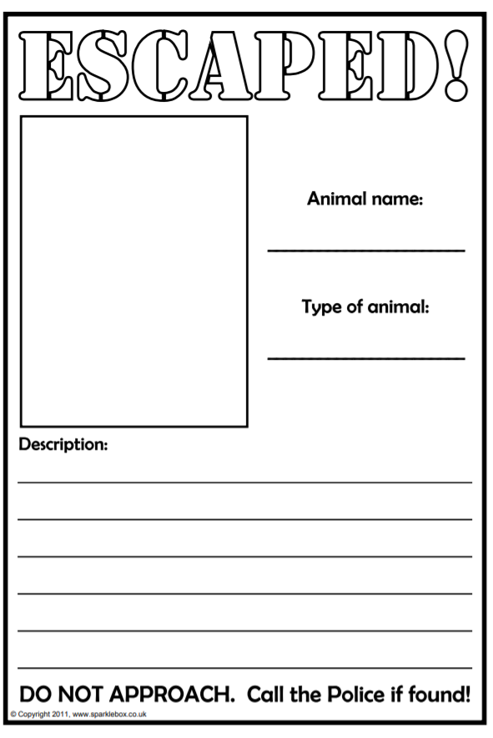

Poems for Senior Infants

This is the sun
This is the sun so big and round
This is the seed snug in the ground
These are the flowers that wave in the breeze
These are the yachts that sail in the seas.

April
April is a rainbow month
Of sudden Springtime showers
Bright with golden daffodils
And lots of pretty flowers

Ice cream, Ice cream
Ice cream, ice cream in a bowl
(make circle with hands)
Ice cream, ice cream, nice and cold
(shivering motion)
Ice cream, ice cream what a treat
(clap 3 times)
Ice cream, ice cream good to eat
(Rub tummy)

Maths Rhyme
2,4,6,8,
Meet me at the garden gate
If I’m late do not wait
2,4,6,8

