Maths
I have set the class up on happy numbers which is a nice online maths programme where they will initially complete a little test and then the future work will be specifically tailored to their ability. They should be able to use this independently if you wish.
Follow these simple steps to use Happy Numbers at home:
1. Go to HappyNumbers.com
2. Click the “I’m a Student” button
3. Enter our class number (493672)
4. Select your child’s name from the class list
5. Enter your child’s password (It is their first name)
Busy at Maths can be accessed through this link
https://my.cjfallon.ie/dashboard/student-resources/?levels=0&classes=0&subjects=0&serieses=0&booktitles=0&types[0]=Book+Sample&utm_source=sniply&utm_campaign=sniply&utm_medium=sniply

Pattern 3 pages 140,141, 142, 143

We have a lot of work already covered on patterns in Maths. Remember the odds and evens, counting in 2’s, counting in 5’s and counting in 10’s. Before Easter you worked on counting in 5’s, 10’s, 6’s and 3’s.
I am going to link some online activities that correlate (goes with) with each page of Pattern 3. You will be working as a maths detective. You have to figure out the pattern and the rules. You can use your 100 square from your homework diary to help you.
p140 group counting
http://data.cjfallon.ie/resources/19626/activity-140/index.html
p141 figuring out the pattern
http://data.cjfallon.ie/resources/19626/activity-141/index.html
p142 algebra figuring out the pattern
http://data.cjfallon.ie/resources/19626/activity-142/index.html
p143 extending and using patterns in algebra
http://data.cjfallon.ie/resources/19626/activity-143/index.html

Work it Out
week 27 p 56 and p 57
*I have put up the answers for last week on classdojo if you want to correct your own book.

Gaeilge
As I emailed before the holidays, Bua na Cainte can now be downloaded at home. To access Bua na Cainte's interactive programme at home, for a limited period, please follow the instructions below.
1. Go to http://www.edco.ie/bua
2. Select the file which suits your computer PC or MAC
3. Select the Class Level you require, and then click on it to start a download of the file. (download direct)
4. Once the download has completed, click on the file to install and follow the on-screen instructions.
5. A Bua na Cainte icon will appear on your desktop. Once you select this icon a login page will open where you will need to enter the details included below.

The login details below can be used for all class levels. Please note that Bua na Cainte only works on PC and Mac computers.

Login: trial
Password: trial

Éadaí
Login in to the Bua Na Cainte programme and select the relevant ceacht for that day. To get the text to appear on the screen just click on the mouse holding the book on the bottom left of the screen, then select play. Once they have listened to the comhrá several times they can then choose to play some of the games by selecting the controller on the bottom right. Once completed then the pupil can do the correlating page in their book. The children are very familiar with this programme and should be able to navigate and use it independently. Please contact me though if you require any help with it.

Litriú
Lch 130 Uimhreacha
Again there is a tool in the programme that we use in school. If you go into Bua na Cainte and select Litriú and then this week’s lesson Uimhreacha the children will know what to do as we do it in school.
Ceacht 3

The focus of this lesson is to enable the pupil to describe how someone who is male is dressed. They keywords are sé (he) and air (on him). This is the text covered in this lesson:

A ___, tar amach anseo. (Oisín, Ruairí, Liam) A ___, conas atá sé gléasta? (Niamh, Róisín) Tá ___ air. Conas atá sé gléasta? Tá ___ air. (culaith spóirt, bróga spóirt, t-léine, bríste gearr,stocaí bána, bróga dubha, léine bhán, bríste dúghorm, geansaí dúghorm).

Bí ag léamh Lth 67
Seo é Ruairí. Tá bríste gearr air. Tá t-léine air. Tá stocaí air. Tá bróga air.
Bí ag Scríobh Lth 67
(The pupil writes about Oisín’s clothes and labels Ruairí’s clothes.)
Déanann na páistí cur síos ar na héadaí atá ar Oisín. Scríobhann na páistí faoi éadaí Oisín: ‘Tá ___ air.’ (geansaí, léine, carbhat, bróga, stocaí)
Cuireann na páistí lipéid ar éadaí Ruairí. (briste gearr, t-léine, stocaí, bróga).

Ceacht 4
The focus of this lesson is to further enable the pupil to describe how someone male is dressed. They can also express their appreciation of a picture.

This is the text covered in this lesson:

Féach ar mo phictiúr. Is foghlaí mara é. Conas atá sé gléasta? Tá ___ air. (hata dubh, bríste donn, cóta dearg, crios buí, bróga corcra) Tá éan ar a ghualainn. Tá scian ina lámh. Tá bosca mór airgid aige. Is breá liom do phictiúr. Tá do phictiúr go hálainn.

Bí ag léamh
Lth 68 (The pupil reads the instructions and follows them to draw and colour the pirate.)
Léann na páistí na treoracha: ‘Tarraing foghlaí mara,’ srl. Leanann na páistí na treoracha chun foghlaí mara a tharraingt agus a dhathú. Tuairiscíonn na páistí faoin bhfoghlaí mara a tharraing siad: ‘Tharraing mé foghlaí mara.’ ‘Tá ___ air.’
Ceacht 5
The focus of this lesson is to enable the pupil to describe how someone who is female is dressed. The keywords are sí (her) and uirthi (on her). This is the text covered in this lesson:

A ___, tar amach anseo. (Niamh, Róisín, Áine) A ___, conas atá sí gléasta? (Ruairí, Niamh) Tá ___ uirthi. (freisin) (éide scoile, léine bhán, carbhat dearg, geansaí dúghorm, sciorta dúghorm, stocaí bána, bróga dubha, gúna dúghorm, culaith spóirt, bróga spóirt) Ar fheabhas ar fad. Maith thú!

Bí ag léamh
Lch 69
Léann na páistí na habairtí faoi éadaí Niamh. Seo í Niamh. Tá bríste gearr uirthi. Tá t-léine uirthi. Tá stocaí uirthi. Tá bróga uirthi.

Bí ag Scríobh
lch 69(The pupil writes about Róisín’s clothes and labels Niamh’s clothes.)
Cuireann na páistí lipéid ar éadaí Niamh. (briste gearr, t-léine, stocaí, bróga). Scríobhann na páistí faoin éide scoile atá ar Róisín: ‘Tá ___ uirthi.’ (léine, geansaí, sciorta, carbhat, stocaí, bróga).

Ceacht 6
The focus of this lesson is to further enable the pupil to describe how someone who is female is dressed. The keywords are sí (her) and uirthi (on her).This is the text covered in this lesson:

Cé hí? Is ___ í. (garda, bean an phoist) Conas atá sí gléasta? Tá ___ uirthi. (léine ghorm, carbhat dúghorm, cóta dúghorm, bríste dúghorm, bróga dubha)

Bí ag léamh
Lch 70
Léann na páistí faoi na héadaí atá ar an ngarda. Tuairiscíonn na páistí faoi na héadaí atá ar an ngarda.

Bí ag Scríobh
lch 70 (The pupil labels and writes about the garda’s clothes.)
Scríobhann na páistí na lipéid. Scríobhann na páistí na habairtí: ‘Tá ___ dúghorm uirthi.’ (carbhat, bríste, cóta dúghorm, bróga dubha, léine ghorm) Léann na páistí na habairtí atá scríofa acu.

Ceacht 7
The focus of this lesson is to further enable the pupil to consolidate the learning from previous lessons; that we use sé and air for males and sí and uirthi for females. This is the text covered in this lesson:

Seo é Oisín. Tá culaith spóirt agus bróga spóirt air. Seo é Ruairí. Tá bríste gearr, t-léine, stocaí agus bróga air. Seo í Áine. Tá gúna fada, stocaí agus bróga uirthi. Seo í Róisín. Tá t-léine, sciorta fada agus bróga uirthi.)

Bí ag léamh
Lch 71
Léann na páistí an abairt chuí do gach pictiúr.

Bí ag Scríobh
lch 71 (The pupil chooses the correct sentence for each picture and writes it underneath.)
Roghnaíonn na páistí an abairt chuí do gach pictiúr. Scríobhann na páistí na habairtí.

English
You can access Starlight online https://auth.folensonline.ie/login?signin=1586cb3347a58c05deca99d272509a0c
Username: secondclassrox@gmail.com Password:password

I will add direct links to these activities but you will also find them when you login on the left hand side of the screen under my favourites. I will update these on a weekly basis for the story/grammar however the poster will be updated on a fortnightly basis. (see picture)

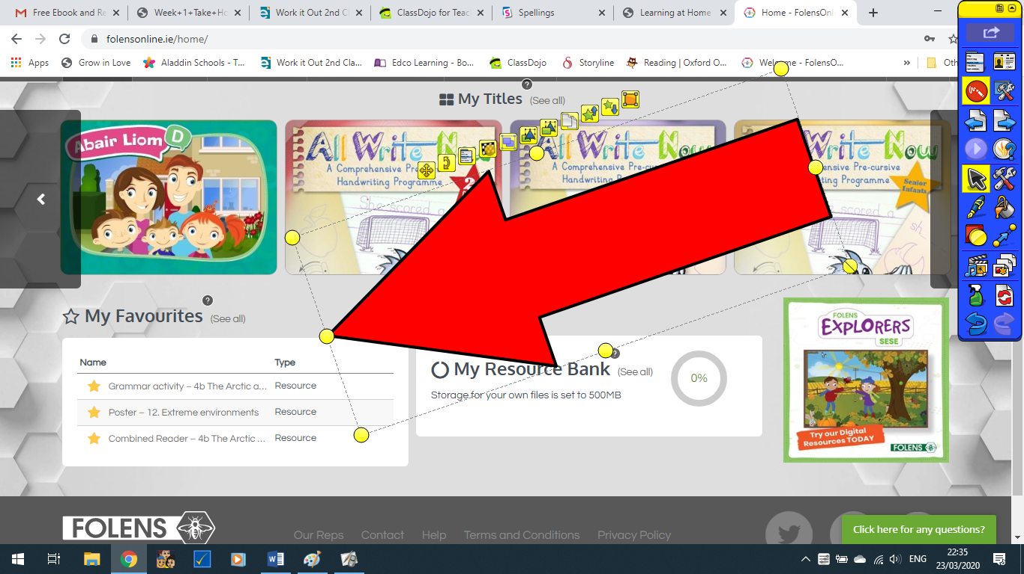

Starlight
Unit 5b Poetry p42 and 43
https://content.folensonline.ie/programmes/Starlight/2nd_class/resources/activities/SL_02_ACT_CH13_011/index.html
The book company have videos now of the focus words and also of the poems being read so you no longer have to listen to me read them however, I will still record the skills page and put them on classdojo if the pupils want help with reading the questions.

Grammar P44 in Starlight

We have some work on replacing common words covered in class. So this should be easy for the pupils to complete in their skills but if they have time it would be no harm to allow them to play the online game first. We are looking for words we can use instead of “said” and “nice”.

Grammar Game
https://content.folensonline.ie/programmes/Starlight/2nd_class/resources/activities/SL_02_ACT_CH13_007/index.html
username: secondclassrox@gmail.com and password: password

P. 45 Starlight

Using the work you did before the Easter holidays, you are now going to erite a list poem. Remember to write your own name as you are the poet who created this poem.

Oral Language poster for this week is the same as the week before Easter
https://content.folensonline.ie/programmes/Starlight/2nd_class/resources/posters/SL_02_ACT_CH13_013/index.html
again username: secondclassrox@gmail.com
password:password

Phonics
I have attached a sheet you can download that focuses on revision of ‘ou’ making and /ow/ sound as in ouch/mouse. Or you can access it online https://content.folensonline.ie/programmes/Starlight/2nd_class/resources/printables/SL_02_PCM_CH13_001.pdf

Spellings
Please continue to login to spellingsforme and keep working at your own pace. You can also complete Spellbound week 26 (we completed week 25 before we left school) p.54 and p.55.

Religion
To help teachers, students and parents during this difficult time, Veritas is granting free access to their Grow in Love online series. If you would like to access resources for Grow In Love, please follow the instructions below:
Simply login on the www.growinlove.ie website with the following details:

Email: trial@growinlove.ie
Password: growinlove

Then you have to select second class. Then select Theme 7 and then select lesson 2.

Easter is still the theme of Grow in Love this week with a focus on the resurrection.

The women at the tomb
https://player.vimeo.com/video/207599749

The Song for this week is This is the Day I will upload the audio to classdojo.

THIS IS THE DAY
Sing! Sing! Sing alleluia.
This is the day the day Lord has made.
Dance! Dance! Dance alleluia.
This is the day the Lord has made.

1. Let us rejoice and be glad.
This is the day the Lord has made.
Let us rejoice and be glad.
This is the day.
Sing! Sing! Sing alleluia.
This is the day the day Lord has made.
Dance! Dance! Dance alleluia.
This is the day the Lord has made.

2. Play music to honour His name
This is the day the Lord has made
Sing psalms and songs of praise
This is the day.
Sing! Sing! Sing alleluia.
This is the day the day Lord has made.
Dance! Dance! Dance alleluia.
This is the day the Lord has made.

PE
I hope you get active outside everyday that it is dry! However you can log on to gonoodle, look up cosmic kids yoga on youtube kids or use your super troopers book for some lovely indoor exercises.

SESE (Science)
Explore with me p.59 Natural or Man-made?
Recall what you already know about materials. Remember a natural material is one that is found in the environment, it comes from nature. A man-made material is one that people or humans make. It cannot be found in nature or in the environment. This is an online quiz to go with this page.

https://2kmme93vd2739.379dn293jkid829238s93.explorewithme.ie/sc/resources/sorting-sc-7-5/

Geography
Explore with Me p.58

Identify, discuss and explore different locations along the Wild Atlantic Way. (you can log into edco to access this or I have uploaded it to classdojo). Don’t forget to think like a geographer. Where is the Wild Atlantic Way? Name Ireland’s most northerly point? What is Ireland’s most southerly point? Do you already know anything about the Wild Atlantic Way? Have you been to any of the nine counties? Can you name all nine counties? Use the words in the box to help you complete the facts on page 58.

History
Explore With Me p.57

Use the slideshow video (you can log into edco to access this or I have uploaded it to classdojo) and your book to examine photographs of Limerick city and identify examples of continuity and change. Remember to think like a historian. How can you tell if a photo was taken in the past or in recent years? What has changed in the area? What has stayed the same? Do you think that photograph A was taken in your great-grandparents, grandparents or parents were young? What about photograph B? Now answer the questions one to five.

Explore With Me p.60

I want you to have a think about your favourite place outside your home.
A favourite place might be in another county or country that you might have visited on holiday or somewhere local that you like to go, such as the park, the seaside, school, Granny's house etc. Now look at the slideshow video (uploaded to classdojo or sign into edco) and examine the photographs of children in their favourite places.
Next I want you to ask someone in your house or a relative on the phone where their favourite place is and if they have any old photograph of that place. If you have an old photo you can stick it onto p. 60. If not, you can get the person to describe it and you can draw it.

Music
Out of the Ark have added more lovely free songs you can access weeks 1,2,3,4 and 5 on this link:
https://www.outoftheark.co.uk/ootam-at-home/?utm_source=homepage&utm_campaign=ootamathome2&utm_medium=banner

Create a Rhythm Pattern
Here is a nice online game
http://data.cjfallon.ie/resources/readytorock/Int_04.html

Shake Beat and Scrape
Another online game: sort the instruments into the correct box
http://data.cjfallon.ie/resources/readytorock/Int_03.html

Art
I have included three pages from the An Post ImagineNation as an attachment but there are plenty of ideas on the “other” padlet that is linked on classdojo.

You can email me if you need any further help msnimhurchu@gmail.com or contact me on classdojo

