Maths
Rotations and Angles

Busy at Maths p.122 and p.123

Things that turn!
Ask your child to think of as many objects as s/he can that turn and to compile a list of these objects, for example, bottle lid, tap, door knob, Ferris wheel, wheel on a car, merry-go-round, spinning top.

Role-play: Army turns!
Ask your child to stand up and to face towards you. Tell him/her that you are going to play the role of an army drill sergeant and that s/he will be the soldier. The soldier must follow the instructions called out by the drill sergeant (you):

- Make a quarter turn (always to the right/clockwise).
- Make a half turn.
- Make a full turn.
Check that your child is facing in the correct direction after each instruction. Always return your child to the forward facing position before giving the next
instruction!
Variation: Ask your child to be the drill sergeant.

Making Angles

Explain to your child that an angle is made when two straight lines meet. Give your child a scissors or two lollipop sticks (or something similar). Ask him/her to make big and small angles with the two lollipop sticks or by opening the scissors. Ask your child to make an angle that is ‘bigger/smaller than’ a particular angle.
Right Angles

Explain to your child that a ¼ turn is a right angle. Invite your child to explore how s/he can make right angles with his/her body, for example:

- Bending his/her arm at the elbow
- Bending his/her leg at the knee
- Sitting on the floor with his/her legs out straight (legs and back at right angles)

Online activity
http://data.cjfallon.ie/resources/19626/activity-122/index.html
Online activity
http://data.cjfallon.ie/resources/19626/activity-123/index.html

Subtraction 4

Over the next few days your child will be revising subtraction with renaming. This is where a 10 will need to be exchanged/swapped for 10 single units before subtraction can take place. Your child needs to know the language of subtraction – How many? What’s the difference? tens, units, rename, break, subtract, subtraction, take away, more, less, fewer, count, minus, number sentence/story, count back/forward, subtraction house, short way, estimate, exchange, swap, etc.
Here is a nice video of a little girl showing subtraction with and without renaming. https://www.youtube.com/watch?v=pADFYrGdyYE

Busy at Maths p.152

Subtraction with Renaming
On this page we are revising subtraction with renaming and doing the sums the short way. I have uploaded a tutorial on classdojo, I suggest you watch this first. I have also uploaded and linked below an online activity that correlates with this page. Read the number problem in the yellow box at the top of the page. Point to the crayons in the first subtraction house and ask questions, such as:
- How many loose crayons are there? (Yes, four.)
- How many groups of 10 crayons are there? (Yes, three.)
- How many crayons are there altogether? (Yes, 34.)
- Can we take 6 from 4?
- What must we do? (Yes, rename a ten as units.)
- We must cross out the three tens and replace them with two tens to remind us that one ten has been renamed as ten units.

Point to the crayons in the second subtraction house and ask:
- How many loose crayons are there? (Yes, 14.)
- How many groups of 10 crayons are there now? (Yes, two.)
- What did we do with one group of ten crayons? (renamed/swapped, etc.)
- How many crayons are there altogether? (Yes, 34.)
- So, three tens and four units is the same as two tens and 14 units.
- How many loose crayons do we need to cross out/take away? (Yes, six.)
- How many loose crayons are left? (Yes, eight.)
- How many groups of ten crayons do we need to cross out/take away?
- (Yes, one.)
- How many groups of ten crayons are left? (Yes, one.)
- So, 34 crayons take away 16 crayons leaves 18 crayons or 34 – 16 = 18.

Do the same with the other questions on this page.

Online activity
http://data.cjfallon.ie/resources/19626/activity-152/activity-152/index.html

Busy at Maths p.153

Subtraction with Renaming

Today we are focusing on an even shorter way of subtracting a two-digit number from a two-digit number with renaming. Again I have uploaded a tutorial on Classdojo that they should watch first. Point to the yellow box at the top of the page. Get your child to read the question.

Ask your child questions, such as:
- How many units do we want to take away? (Yes, seven.)
- Can we take 7 from 4?
- What must we do? (Yes, rename a ten as units.)
- We must cross out the six tens and replace it with five tens to remind us that one ten has been renamed as ten units.
- We place a small 1 in front of the four units to remind us that one ten has been renamed as ten units and that we now have 14 units.
- We can now take away the 17 very easily.

Do the same with Questions 1, 2 and 3.
Challenges: Point to the Challenges at the bottom of the page. Explain that the Challenges are based on the subtraction activities that have been done earlier on the page. Give your child some cubes, counters Lego bricks or any base ten materials and ask them to come up with strategies to solve the Challenges.

Online activity
http://data.cjfallon.ie/resources/19626/activity-153/activity-153/index.html

Busy at Maths p.154

Subtraction with Renaming C
This page continues the formal algorithm for subtraction of a two-digit
number from another two-digit number with renaming. As we have plenty of work covered on this your child should be comfortable completing this page. However, this page also contains subtraction sums that do not require renaming. I suggest highlighting to your child that they need to be Maths detectives on this page and check each sum carefully before renaming.

Challenge:
Point to the Challenge at the bottom of the page. Explain that the
Challenge is based on the subtraction activities that have been done earlier
on the page. This question is given in a different format to most of the other
questions. Ask the children to come up with different strategies to solve the
Challenge.

Online activity
http://data.cjfallon.ie/resources/19626/activity-154/index.html

Busy at Maths p.155

Addition and Subtraction
The questions and Challenges on this page are a revision of work done on
addition and subtraction to date. It is vitally important that the children don’t
get into a rut of only doing one or the other operation. Both operations need
to be given together with and without renaming or regrouping. Encourage your child to carefully check each sum before starting. Is this sum addition or subtraction? If it is addition, does it require regrouping? If it is subtraction, will I need to rename?

Online activity
http://data.cjfallon.ie/resources/19626/activity-155/index.html

Work it Out
We have finished the book! Well done! We are going to do a Friday Test each day now to finish those up too. I think we finished on test week 23 in school. So this week can you try week 24 on page 77, weeks 25 & 26 on page 78 and weeks 27 & 28 on page 79. I know some of you had complete the wrong test the last Friday we were in school so if you have test 24 done you might need to do test 23. I will put the answers for tests 23-28 up on Friday and you can correct them. Remember if you want me to correct them just take a photograph and send it to my email or classdojo. Best of Luck!
*I have put up the answers for last week on classdojo if you want to correct your own book.

Gaeilge Sa Bhaile
Litriú Lch 134 An Réamhfhocal - Ag

Again there is a tool in the programme that we use in school. If you go into Bua na Cainte and select Litriú and then this week’s lesson Ag the children will know what to do, as we do it in school. This week the focus is on to have:
agam I have
agat you have
aige he has
aici she has
Tá cat agam. I have a cat.
Tá madra agat. You have a dog.
Tá bó aige. He has a cow.
Tá muc aici. She has a pig.
Ceacht 10
The focus of this lesson is to enable the pupil to express that they would like a drink/food.

This is the text covered in this lesson:
Fáilte romhat isteach. Go raibh maith agat. Suigh síos agus lig do scíth. Suífidh mé. Ar mhaith leat ___? Ba/Níor mhaith liom ___. (deoch, ceapaire) Tá/Níl ___ orm. (tart, ocras) Ar mhaith leat cluiche a imirt? Ba mhaith liom. Ar fheabhas. Come in, welcome. Thank you. Sit down and have a rest. I will sit. Would you like___? I would/would not like_____ ( a drink, sandwich). I am/am not _____. (thirsty, hungry). Would you like to play a game? I would like to. Great!

Bí ag léamh
Lch 82 (The pupil reads the labels and the sentences.)
Léann na páistí na lipéid chuí do gach pictiúr.
Léann na páistí na habairtí. Cumann na páistí abairt a ghabhann le gach pictiúr.
Bí ag Scríobh
lch 83 (The pupil then finishes the sentences.)
Scríobhann na páistí na habairtí: ‘Ba mhaith liom ___.’ (oráiste, cáis, uisce, banana, ceapaire, cáca, úll, piorra, milseán).
Ceacht 11
The focus of this lesson is to enable the pupil to say: Mammy gave_____ to him/her. Thug Mamaí _____ (uachtar reoite, úll, oráiste, piorra, deoch, banana) dó/di.

dó to him
di to her

This is the text covered in this lesson:
Bhí Oisín agus Niamh ag an mbord. Bhí siad ag imirt cluiche. Tháinig Mamaí isteach sa chistin. Dia daoibh. Conas atá sibh? Dia’s Muire duit, táimid go maith, go raibh maith agat. A Mhamaí, ba bhreá liom uachtar reoite. D’oscail Mamaí an cuisneoir. Thug Mamaí uachtar reoite di. Go raibh maith agat. Thug Mamaí uachtar reoite dó. Bhí na páistí an-sásta. Oisín and Niamh were at the table. They were playing a game. Mammy came into the kitchen. Hello (plural) how are you (plural)? Hello (singular) We are good, thank you. Mammy, I would love ice-cream. Mammy opened the fridge. Mammy gave ice-cream to her. Thank you! Mammy gave ice-cream to him. The children were very happy.

Bí ag léamh
Lch 83 (The pupil reads the labels and the sentences.)
Léann na páistí na lipéid chuí do gach pictiúr.
Léann na páistí na habairtí: ‘Thug Mamaí ___ dó.’ (úll, oráiste, piorra, banana, cáca) ‘Thug Mamaí ___ di.’ (uachtar reoite, úll, oráiste, piorra, banana, cáca) Cumann na páistí abairt chuí a théann le gach pictiúr.

Bí ag Scríobh
lch 83 (The pupil then finishes the sentences.)
Scríobhann na páistí na habairtí.

Ceacht 12 An Nuacht/An Aimsir
At the end of every theme we complete one of these lessons. The focus is on key vocabulary from the theme as well as revising vocabulary associated with weather and the news. This is the text covered in this lesson:
An Nuacht
An nuacht á léamh ag Niamh. Inniu an Mháirt. Inné an Luan. Amárach an Chéadaoin. Tháinig Mamó go dtí mo theach. Tháinig sí ag a dó a chlog. Thug sí cúig euro dom. Bhí áthas orm. An bhfuil scéal agat? Tá scéal agam. Tháinig Daideo go dtí mo theach. Thug sé leabhar dom. Bhí áthas orm. The news read by Niamh. Today is Tuesday. Tomorrow will be Wednesday. Mamó came to my house. She came at 2 o’ clock. She gave me five euro. I was happy. Have you any news/a story? I have a story/some news! Daideo came to my house. He gave me a book. I was happy.
An Aimsir
Anois an aimsir á léamh ag Oisín. An t-earrach atá ann. Bhí an lá go deas inné. Bhí sé te agus tirim. Tá an lá fliuch inniu. Tá sé ag cur báistí. Beidh sé scamallach amárach. Beidh an ghaoth ag séideadh. Now the weather read by Oisín. It is Spring. It was a nice day yesterday. It was hot and dry. The day is wet today. It is raining. It will be cloudy tomorrow. The wind will be blowing.

Bí ag léamh
Lch 84 (The pupil read the news and weather forecast.)
Léann na páistí an nuacht atá scríofa acu.

Bí ag Scríobh
lch 84 (The pupil finishes the sentences to give the news and weather forecast.)
Críochnaíonn na páistí na habairtí chun an nuacht agus an aimsir a thabhairt. Scríobhann na páistí an nuacht agus an aimsir.

Scéal
At the end of each theme there is a story. The children again are used to this structure and they love the song. You will find the story on the bottom left of the screen when you sign into Bua na Cainte and click into this week’s theme Éadaí. This is an Irish version of The Boy Who Cried Wolf!
This is the text covered in this lesson:

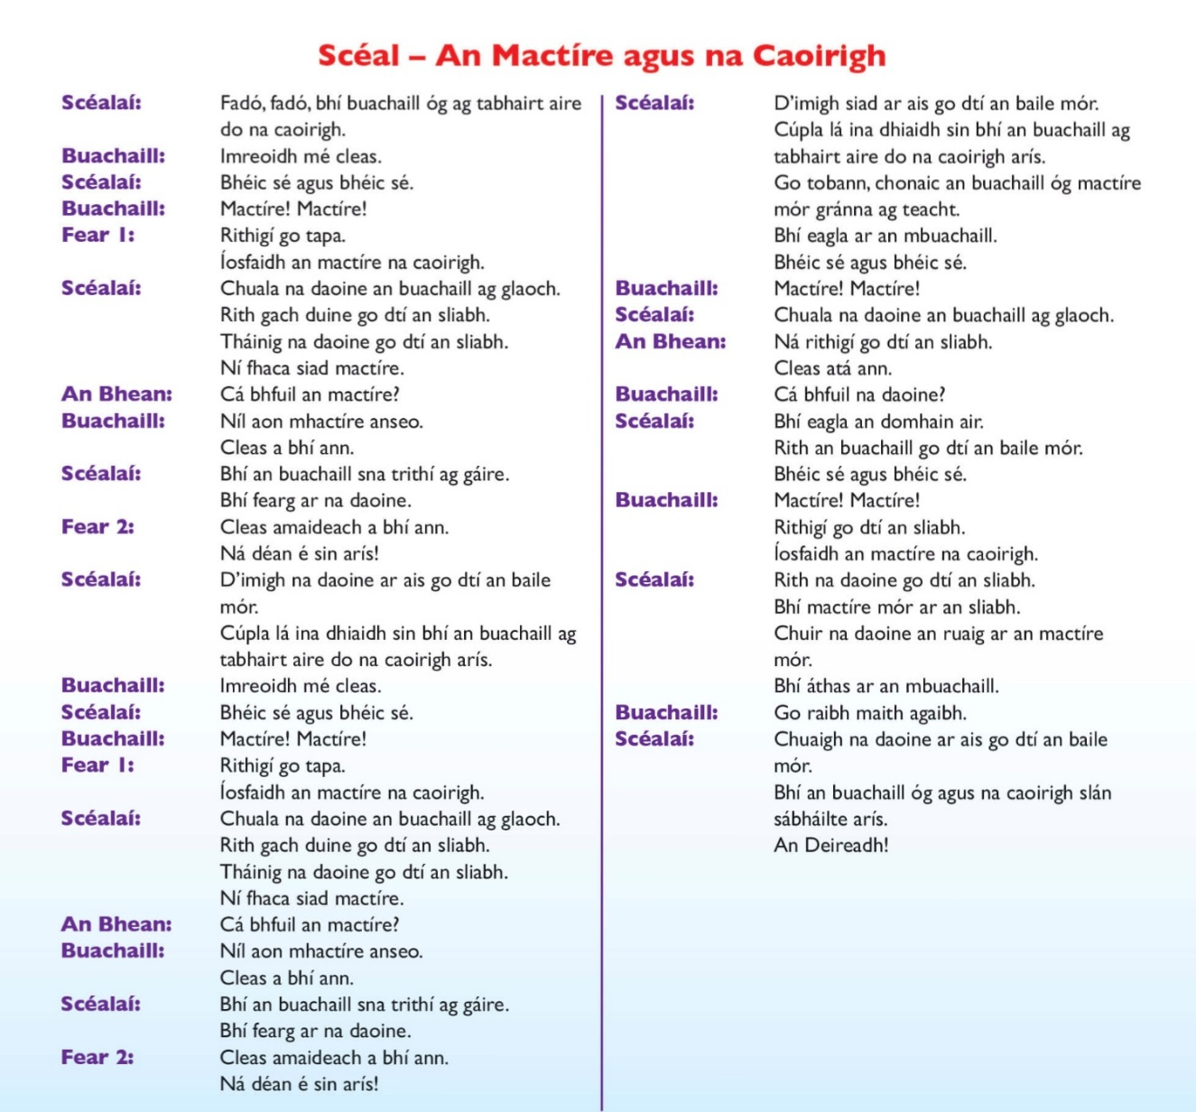
Bí ag léamh
Lch 85
Léann na páistí na lipéid chuí do gach pictiúr.
Bí ag Scríobh
lch 85 (The pupil chooses the correct colours and colours the picture accordingly.) Dathaíonn na páistí an pictiúr.

English
You can access Starlight online https://auth.folensonline.ie/login?signin=1586cb3347a58c05deca99d272509a0c
Username: secondclassrox@gmail.com Password:password

Starlight
Unit 7b Narrative p58 and 59
https://content.folensonline.ie/programmes/Starlight/2nd_class/resources/activities/SL_02_ACT_CH15_011/index.html

The week our focus is again on narrative writing and reading. Remember a narrative tells a story. It can be real or imaginative, but it always has the same purpose: to entertain the reader. A narrative always has a setting- when and where the story takes place. A narrative also has characters, these can be people, animals or even things that only come to life in the story such as toys. A narrative also has a plot. The plot is what happens in the story. The events of the story make up the plot. Sometimes the plot of the story includes a problem that needs to be solved. This can help to make the story interesting. The problem is usually resolved or fixed near the end of the story. This is called the resolution.
The focus words this week are: enchanted, slanted, mist, swirled, stretched, tremendously, carousel, distant

Discussion After Reading
- A narrative text tells us a story. The story can be real or imaginary. Look at the title of this story. Do you think it will be real or imaginary?
- Narrative texts always have characters. Joe is a character in this story. Who are the other characters?
- Narrative texts use lots of descriptive language or lots of adjectives. Look at the sentence: ‘Above him the enormous thick white cloud stretched.’ The author used three adjectives to describe the cloud. Can you find other examples of descriptive language in this text?
- Do you know what a carousel is? In what ways was standing in the new, strange land like being on a carousel?
- Narrative texts have some dialogue between the characters. They talk to each other in the story. ‘What’s happening?’ said Beth is an example. Can you find another example of dialogue or direct speech in this text?
- Have you ever been dizzy? Did you feel scared? Discuss with your partner.
- What do you think happens next in this story? Discuss.

Grammar P56 in Starlight – Comparing Adjectives

When comparing two things we add er to the end of the adjective for example Ms Ni Mhurchú’s hair is short but Mr. Leahy’s hair is shorter. If we are comparing a three or more things we add est to the end of the adjective. Mary’s bag is small, Brian’s bag is smaller but Mark’s bag is the smallest.

Grammar Game https://content.folensonline.ie/programmes/Starlight/2nd_class/resources/activities/SL_02_ACT_CH15_007/index.html
username: secondclassrox@gmail.com and password: password

P. 61 Starlight
Children use p. 61 of the Combined Reading and Skills Book to complete a character profile of their own superhero. A range of adjectives is provided to support children in writing an imaginative and interesting description of their superhero.

Oral Language poster for this week and next is Adventures with Authors
https://content.folensonline.ie/programmes/Starlight/2nd_class/resources/posters/SL_02_ACT_CH15_013/index.html
again username: secondclassrox@gmail.com
password: password

Oral Language
Digital poster (Story mode):
- Play either the Story mode 1 (starters) or Story mode 2 (flyers) for the children again. Make sure they understand all of the vocabulary.

Digital poster (Explore mode): Talk and discussion
Go to the Explore mode of the poster. Ask children the following questions:
- Spotlight on the book cover of The Boy in the Dress If you cannot spotlight just draw your child’s attention to the specific book cover. Ask the pupil(s) the following questions:
- What do we call the front part of the book? (Book cover)
- What does the book cover do? (Makes us want/entices us to read the book)
- What can we tell from the cover of a book? (Title, author, illustrator, description, genre)
- What information do we get about this book from the cover?
- What words are used in the description to give us information about the book? (Hilarious, bestseller)
- What do these words suggest about the book? Do you think they are good words to entice us to read the book? Why?
- Is this a true story? (Fiction: A made-up story from the author’s imagination)
- Explain to the children about other genres of stories. Fantasy: A story which has strange/unusual characters, events, places; Mystery: A story about something which is puzzling.
- Besides words, what else do we notice about the cover of The Boy in the Dress? (e.g. image, colour, type/size of font)
- Scaffold the children to give an account of what they know about this book based on the information on the cover. Encourage the children to present three or four complex sentences (e.g. This is a book called The Boy in the Dress, written by David Walliams and illustrated by Quentin Blake. It is a very funny story which a lot of people are buying because it is a very funny book. The cover has a picture of a boy kicking a football. This is a fictional story. I would/would not like to read this book because…)
- Spotlight each of the book covers and explore in a similar manner.

Follow this with a discussion on the idiomatic phrase Don’t judge a book by its cover. When we look at a book cover and try to guess what kind of book it is and what it will be about, are we always right? Explain that you can’t tell what’s inside a book just by looking at its cover, and you can’t always tell what’s inside a person from what you see on the outside. Encourage children to think of a time when they made a judgement (about a book/person) but were proved to be wrong.

Poem Mode:

The Writer of this Poem
By Roger McGough

The writer of this poem
Is taller than a tree
As keen as the North wind
As handsome as can be

As bold as a boxing glove
As sharp as a nib
As strong as scaffolding
As tricky as a fib

As smooth as an ice cream
As quick as a lick
As clean as a chemist shop
As clever as a tick

The writer of this poem
Never ceases to amaze
He's one in a million billion
(or so the poem says!)

Encourage children to speak the poem aloud with appropriate actions and expression. Ask the following questions:
  - An author is someone who writes stories. What do we call someone who writes poems? (Poet)
  - What is the difference between a story and a poem? (Length, rhyme)
  - Who is the poet in this poem talking about? How do you know?
  - How does this poet describe himself? Is his description positive/negative?
  - How does he make his description clear? (Similes)

Spellings
Please continue to login to spellingsforme and keep working at your own pace. You can also complete Spellbound week 30 p.62 and p.63. The silent l spellings are the only tricky ones this week.

Religion
Simply login on the www.growinlove.ie website with the following details:

Email: trial@growinlove.ie
Password: growinlove

Then you have to select second class. Then select Theme 9 and then select lesson 1.

God Created Us
Watch the videos before you complete the pages in your workbook.
Prayer
May is the month that we celebrate Mary. We would love if you thought of Mary this week, by saying the “Hail Mary” prayer each time you pray.

Grow in Love p. 50 and 51
This week we are thinking about the gifts and talents that God has given each person. We all have different gifts and talents. Everyone’s gifts and talents are important.

Theme 9, Lesson 1– Thank you, Lord, for making me
https://vimeo.com/173789159

Theme 9, Lesson 1 Poem - I am unique
https://vimeo.com/173789160

Theme 9, Lesson 1 God Created People
https://vimeo.com/201877274

This week’s song : Gifts from God
https://www.youtube.com/watch?v=7yfYj-8XrBc

Gifts from God

1. We have been called to love the Lord, our God
We have been called to glorify his name
We have been called to love the Lord, our God
We have been called to glorify His name.

Use your skills, use your talents,
Use the gifts you have been given.
We’re all diff’rent, we’re all we’re all special in this world.
Use your skills, use your talents, use the gifts you have been given.
Give God glory, love all others, love our world.

2. We have been called to care for all our friends
We have been called to watch for everyone
We have been called to care for all our friends
We have been called to watch for everyone.

Use your skills, use your talents,
Use the gifts you have been given.
We’re all diff’rent, we’re all we’re all special in this world.
Use your skills, use your talents, use the gifts you have been given.
Give God glory, love all others, love our world.

3. We have been called to care for this, our world
We have been called to marvel at God’s work
We have been called to care for this, our world
We have been called to marvel at God’s work.

Use your skills, use your talents,
Use the gifts you have been given.
We’re all diff’rent, we’re all we’re all special in this world.
Use your skills, use your talents, use the gifts you have been given.
Give God glory, love all others, love our world.

PE
This week I will be uploading three FAI home skills videos to help you practise your soccer skills at home. I will also upload some extra PE ideas like previous weeks on classdojo.

SESE (Science)
Explore with me p.75 Floating or Sinking
In this lesson you will be investigating floating and sinking.

First you will need to gather the equipment required.

Equipment: A basin or container of water, a spoon, a stone, a straw, a leaf, a crayon and a ruler.
Open your book on p.75: You must predict which of the six items will float or sink. Then carry out your experiment and write in the results.

If you have a lemon and a lime at home, you can try to figure out the fascinating fact. If not, don’t worry I will upload a video showing which floats and which sinks on Friday.

Also for the plasticine experiment I suggest you substitute the plasticine with something you might find in your home and just predict if that will float or sink. I’m not sure playdoh will work as in my experience it gets sticky when wet.

Also, I would like you to predict if an orange will float or sink. Test it! After you test it I would like you to peel it and test again. Did you get the same result? Why do you think that is?

Geography
Explore with Me p.74 Belfast and New York: City Fact File

Today you will become familiar with some aspects of the lives of people in Belfast and New York. Have you been to Belfast? What do you know about Belfast? Have you ever been to New York? What do you know about New York?

Watch the short slideshow on Belfast and New York on classdojo.

Interesting Facts

Belfast
- The pneumatic tyre was invented in Belfast by John Wood Dunlop
- ‘Stairway to Heaven’ a famous song by Led Zeppelin, was first performed in the Ulster Hall.
- The tallest building in Belfast is the Obel Tower.
- The Albert Memorial Clock was built in 1865.
- The Harland and Wolff shipyard was founded in 1862. At the time it was one of the biggest shipbuilders in the world.

New York
- The Empire State Building is 381m tall. It only took 410 days to complete.
- Brooklyn Bridge was the first steel-wire suspension bridge in the world. It connects New York and Brooklyn. It took 14 years to build.
- Ellis Island opened in 1892. All new immigrants to the United States of America passed through the station at Ellis Island. Today it is a museum that people can visit.

Pupil book p.74
Read the fact files and answer the questions.

History
Explore with Me p.73 The Titanic

This week we will listen to, discuss and retell the story of the Titanic. You will also record and sequence the main events of the Titanic’s final journey.

Look at the slideshow video I uploaded. Read the facts below and try to remember key events.

FYI

The Titanic was built at Harland and Wolff shipbuilders in Northern Ireland. It took over two years to build and was completed in 1911. It was the biggest ship in the world at the time.

The ship’s maiden voyage was across the Atlantic Ocean from Southampton to New York, stopping at Cherbourg in France and Cobh, Co. Cork (or Queenstown as it was called at the time). The Titanic left Southampton on Wednesday the 10th of April 1912. She stopped in Cherbourg to collect more passengers and docked again, the following day, Thursday the 11th of April, at Cobh to collect more passengers.

She set sail for the last time across the Atlantic Ocean, planning to arrive in New York on the 17th of April. Sadly, she didn’t make it. On the night of the 14th of April, the ship hit an iceberg below water level. The compartments below deck filled with water and the ship began to sink. Less than three hours later, in the early hours of the 15th of April, the Titanic sank. There were approximately 2,200 people on board and only 705 survived. Another ship, the Carpathia, brought the surviving passengers to New York. They arrived three days later on the 18th of April.

Go to page 73 of your book. Read the green box about the Titanic. Record the key events on the calendar on the page. Plot the course of the ship’s journey.

Think like an Historian!
- Where was the Titanic built?
- What was the name of the town of Cobh in 1912?
- How many people survived the sinking of the Titanic?

Explore with Me p.76 Seán the Boat Builder

Today we will discuss the life of a boat builder.

  - First watch the slideshow and listen to Seán tell his story.
  - Next open your book on page 76 and read about Seán’s life as a boat builder.
  - Then examine the photographs of the old and new boat and write two differences and two similarities between them. Remember you can use information you read or watched on the slideshow to help you.
  - Finally imagine that you are a boat builder and write about your work.

Think like a Historian!
- What is Seán’s job?
- Do you think that wooden boat building is a popular trade today? Why?
- What was the tradition when a new boat was bought?
- What do you think wooden boats were mainly used for?

Music
I wanted to focus on two songs this week the first one ties in with our theme of Water in SESE. This song is The Oceans Song you can find it on the link below and I will also upload it on dojo. https://www.youtube.com/watch?v=X6BE4VcYngQ
The second song is I Wanna Be Like You from the Jungle Book. I will upload a video with actions. Here are the lyrics.
I Wanna Be Like You
Now I’m the king of the swingers boy, the jungle V.I.P
I reached the top and had to stop
And that’s what bothering me
I wanna be a man, man-cub, and stroll right into town
And be just like those other men
I’m tired of monkeying around, oh
Ooh-bi-doo, I wan’na be like you
I want to walk like you, talk like you, too
You see it’s true, an ape like me
Can learn to be hu-u-man, too
Now don’t try to kid me, man-cub, I made a deal with you
What I desire is man’s red fire to make my dream come true
So give me the secret, man-cub, clue me what to do
Give me the power, of man’s red flower, so I can be like you, oh
Ooh-bi-doo, I wan’na be like you
I want to walk like you, talk like you, too
You see it’s true, someone like me
Can learn to be like someone like you
(Instrumental)
Ooh-bi-doo, I wan’na be like you
I want to walk like you, talk like you, too
You see it’s true, someone like me
Can learn to be like someone like you
Can learn to be like someone like you
Can learn to be like someone like me

Art
For this week’s art I would like you to try to create a piece of art using things you find in nature. You can be as creative as you like. You can spell out your name, make a smiley face or try making patterns. Here are some I made:

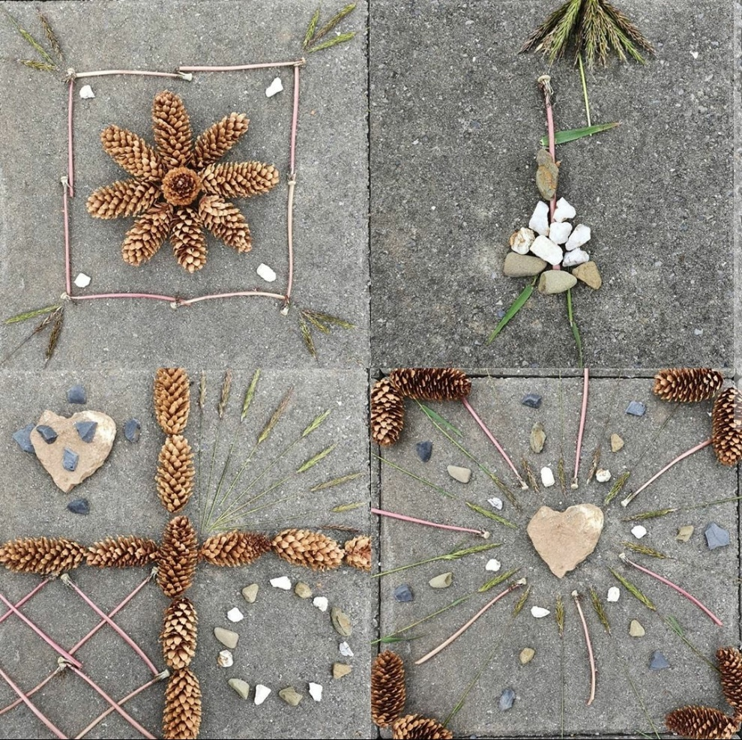

I tried to make different shapes and also a person holding an umbrella. I look forward to seeing what great ideas you come up with!

You can email me if you need any further help msnimhurchu@gmail.com or contact me on classdojo

