Memory games
- Say or sing the alphabet. Stop on one letter of the alphabet and come up with words beginning with that specific letter under certain headings e.g.:
- Girl’s names
- Boy’s names
- Animals
- Country
- Food
- Item of clothing
- Toy

- Memory train game
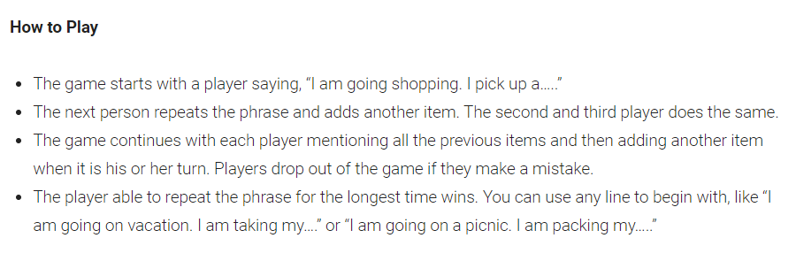
- Spot the difference- A simple game to play anywhere
