Maths Answers for Week 2
You should have 20 Brain teasers done by now. Any problems email us at roxpupils.ias@eircom.net
Make notes of any issues and we can deal with them.
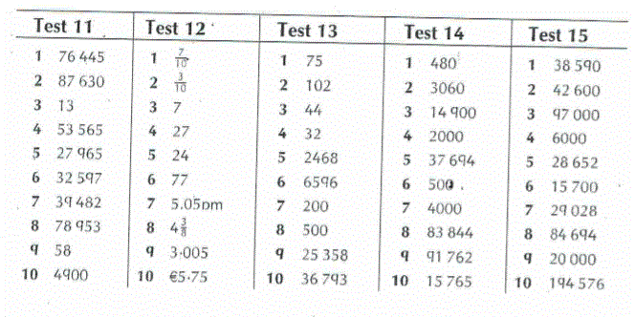
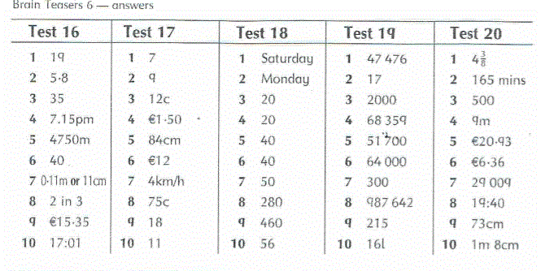

https://educateplus.ie/ppresource/work-it-out-maths-6th-class
Answers to Work It Out are Available through the above address and you can print and finish any further tests if you wish.

You can go to the website for extra Maths e.g. Area or Angles.

Mathemagic 6 Look Back page 140. Answers:

