Please go to https://www.folensonline.ie/registration/?r=t
Simply register as a teacher
Use the special code for the roll number: Prim 20
Search for Starlight Senior Infants
We are on Unit: 15 Theme: Holidays Subtheme: The Fairground
Reading
Our story for this fortnight is called A Ride at the Funfair.
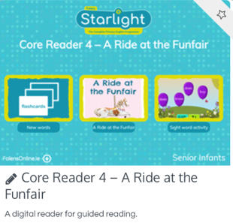

Big Book
You can help your child to read the Big Book unit 15 All the Fun at the Fair
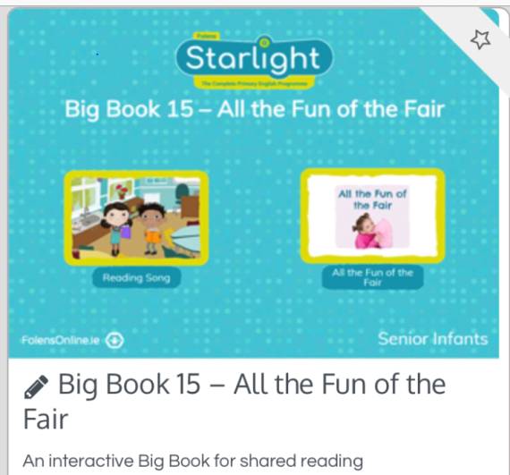
Oral language
The poster in Unit 15 The fairground has lots of fun activities
Storymode, activity mode, label mode and a question mode
