Answers for week 4 learning at Home April 20th – 24th
^{Brain Teasers}
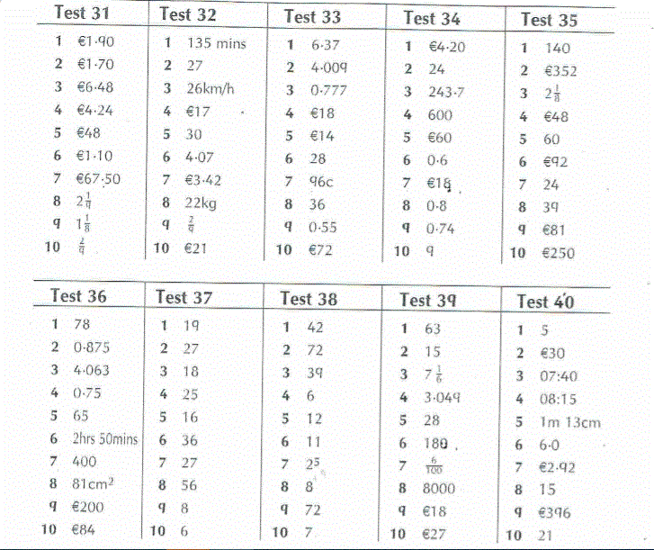
Mathemagic
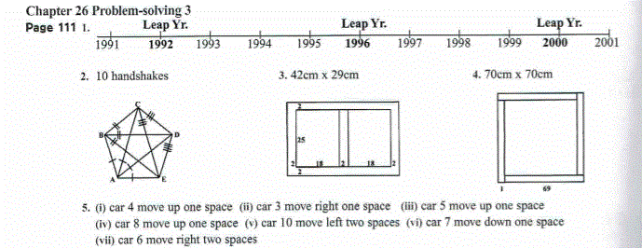
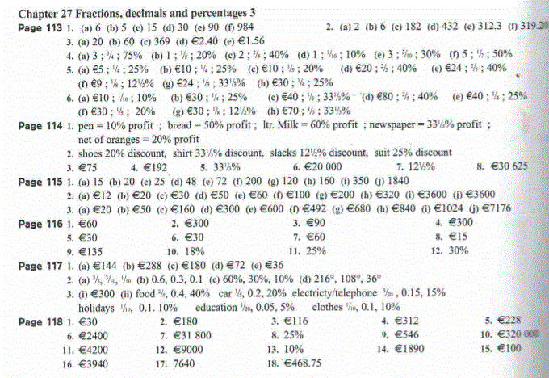

Let us know if you have any questions via google classroom.
You’ll have covered a lot of ground this week – it is a tough maths chapter.

