Plan of work [guidelines] 5th----15th May for Junior Infants:
Dear Parents,
I hope you are all keeping safe and well. Please don’t feel obliged to complete all the activities!
- Maths:
- Money:
- Revision of coins…..sort coins in bundles 1c, 2c, 5c
- Look at 10c coins…sort 10c coins into bundles
- Recognise, sort and name 1c.2c 5c and 10c coins
- Coin rubbings, draw the coins you would need to buy……[*see worksheet]
- Addition within 5c…..complete p.119 and p.120 in Busy at Maths
- Number:
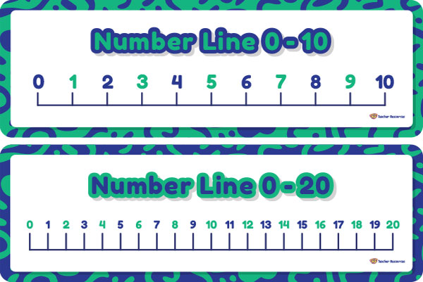
- Count the number from 0---20, count forwards and backward, count from different starting points
- Practise writing the numbers 1, 2, 3, 4,5
- Write out the numbers 0---10 on card…arrange the numbers in order, ask which number comes before/after/in between ,which number is one more than/is one less than, which number is beside/next to, show me the number zero, show me the first/last number
- Stand and sit activity: children stand and sit while saying the numbers 0-20
- Clap and snap activity: children count forward to 20, clapping in time, then count back snapping fingers in time.
- Mix up the numbers and put them in order, turn some numbers upside down, children decide which numbers are missing.
- Complete p.121, p.122, p.123, and p.124 in Busy at Maths
- Writing the number 6 and number 7:
- Count out six objects…. counters, blocks , toys, practise writing the number 6 correctly.[*see worksheet]
- Make sets of 6 things.
- Count seven objects…counters, toys, blocks, spoons, forks….. pactise writing number 7 correctly.[*see worksheet]
- Make sets of seven things.
- Irish…..click on the link to download and install Bua na Cainte on your computer http://www.edco.ie/bua continue the theme “Sa Bhaile” [At Home]
Revision:
Rann:[poem] Féach ar mo theach Dathaigh an teach [colour]
Nach deas é!
Féach ar an díon
Is ar an simléar
Tá na ballai bán
Tá an doras buí
Cé mhéad fuinneog ann?
A haon,a dó,a trí
p.29…Comhair [count]
a haon,a dó, a trí, a ceathair, a cuig, a sé, a seacht, a hocht, a naoi, a deich
Rann:
Simléar oráiste,
Simléar buí
Simléar dearg
A haon,a dó,a trí
Sa spéir…practise the phrases
Cad atá sa spéir? [What is in the sky?] An bhfuil_________ sa spéir? Ta/Nil
Tá an ghrian sa spéir.[sun]
Tá scamall sa spéir.[clouds]
Tá éan sa spéir. [birds]
Tá eitleán sa spéir. [aeroplane]
Tarraing___________ [daw] tarraing an ghrian,tarraing scamall,tarraing éan,tarraing eitleán

Practise the phrases……and complete *worksheet
Cuir ___________ sa ghairdín
Cad atá sa ghairdín? [What is in the garden?]
Tá____________ sa ghairdín.
Tá blathanna sa ghairdín. [flowers]
Tá crann sa ghairdín.[tree]
Tá féar sa ghairdín.[grass]
Tá éan sa ghairdín.[bird]
Tá luch sa ghairdín [mouse]
Tá cat sa ghairdín.
Tá madra sa ghairdín. [dog]
Tá coinín sa ghairdín.[rabbit]

Cad atá ar an mbord.[What is on the table?]
Tá leite ar an mbord.[porridge]
Tá bainne ar an mbord.[milk]
Tá oráiste ar an mbord.[orange]
Tá ubh ar an mbord.[egg]
Tá im ar an mbord.[butter]
Tá subh ar an mbord.[jam]
Tá subh ar an mbord….[úll,milseán, banana,ceapaire,cácá…………apple,sweets,banana,sandwiches,cake]]
An maith leat _________? Is/Ní maith liom [Do you like….?]

English…….[Starlight programme…unit 14]..access www.folensonline.ie register as a teacher, use code/roll number Prim20.
- Reading:
- read the interactive Big Book “The Supermarket Slip-Up” with your child.
- practise the new words for story “Fish and Chips” in Reader 3 every day…..
you, were, said, they, Granny, shops, fish, chips, can’t, bags, lemons, till, cash, love, too
- Read the story p.15-----p.24 and complete p.21---p.24 in the Skills book
- Some free learning websites to explore …
www.storylineonline.net
www.seussville.com
- Oral Language:
- look at poster “The Supermarket” unit 14
- Explore the story mode, explore mode, activity mode, question mode, label mode, and poem mode.
- Play the story At the Supermarket by Anne Rockwell on YouTube
- Practise saying the poem “Shopping Basket” by Charles Thomson
- Have fun with these Food Tongue Twisters ……! [ Can you say them quickly?]
How many cookies could a good cook cook if a good cook could cook cookies?
Red lolly, yellow lolly
A proper cup of coffee from a proper coffee pot
One fish, two fish, red fish, blue fish
I bought a big basket of biscuits from the bakery
- Phonics:
- continue with “Just Phonics” [orange book]
- Fill in the missing letters on p.74 and p.75
- Colour the correct phrase for each picture on p.76
- Make up your own words on p.77
- Practise writing the word on p.78
- Assessment on p.79 and p.80 ….check that your child knows all the initial sounds on p.80
- Check out Jolly Phonics web site on YouTube and www.phonicsbloom.com …look at the online phonics games phase 1 and phase 2[very good and interesting]
- Writing:
- All Write Now book…..th sound on p.45, revision p.46, qu sound p.47
- writing “In the Garden” [*see work sheet]

- P.E/Music…check out the Active Home Week ideas….it is recommended that children need at least 60 minutes of physical activity every day.[World Health Organisation]

- Small World Book:

- Science: Keeping healthy on p.32 and Healthy Food and Drink p.33 [integrate with P.E]
- Geography: Going to the Hospital on p.42
- History: Now and Then on p.43…chat about how schools have changed.. furniture, desks, clothes… look at images in Schools in Ireland in the 1950s on line

- Religion:
Note…you can access the Grow in Love programme online.
Login in on the www.growinlove.ie website with the following details;
Email: trial@growinlove.ie
Password: growinlove
Go to theme 8 “Water”, Look at lesson 1 Water is Wonderful and lesson 2 Welcomed with Water
Practise saying your prayers, listen to the story about Enestina, listen to the song “Water”,
complete p.46 and p.47...We can care for water complete p.47 and p.48 …My Baptism

- Dear Children,
I hear you have all been working very hard. Keep up the great work! I miss teaching you all and listening to your stories! Stay safe…Teacher

Irish worksheet: Dathaigh an teach [colour the house]
Tarraing [ bláthanna, féar,éan,madra, eitleán,samall, an ghrian, coinín,cat,crann ] sa ghairdín. [draw]
Taispeáin dom ____________ [show me]

MONEY WORKSHEET: Draw the coins you would need to buy………..
5c ______________________________________________

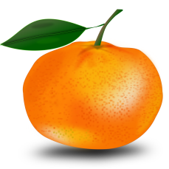3c _________________________________________________

4c ________________________________________________

5c __________________________________________

2c _______________________________________
3c _________________________________________
More challenging work: draw the coins you would need to buy…….
6c _________________________________________________

7c __________________________________________________

8c ______________________________________________

9c ________________________________________________

10c _____________________________________________
7c __________________________________________
writing……..please help your child to use these words and write the story
flowers, butterflies, bird, the sun, sky, blue, clouds, Summer Time, grass, colour…..pink, yellow, purple, blue , brown, green, white, pretty [say the words…read the story]

In the Garden 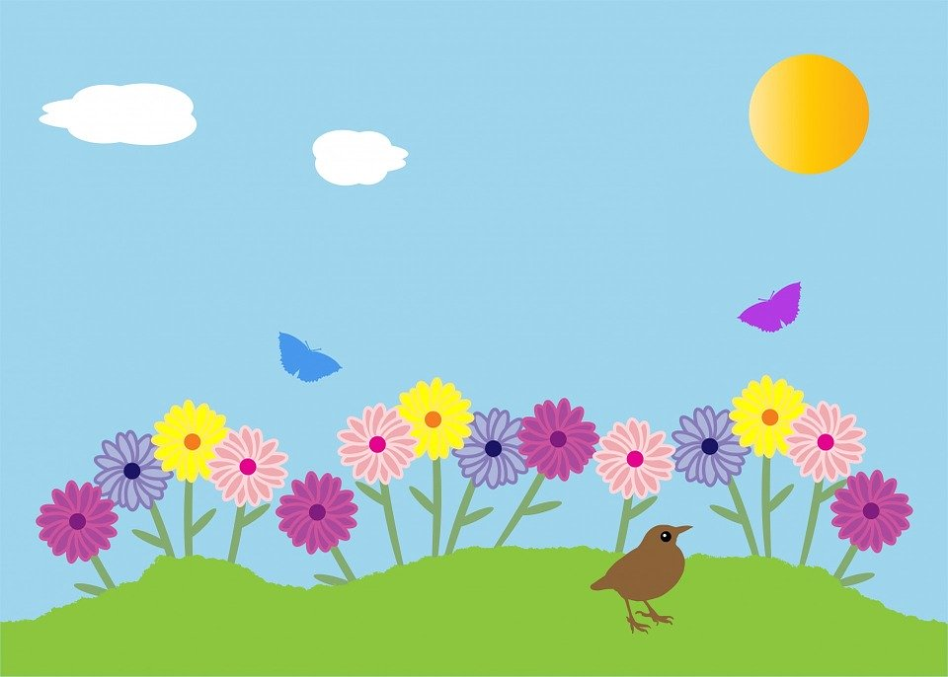
It is S_____________ T____________.
I see ________________________.
I see ________________________.
The flowers are ____________________.
The flowers are _________________.
The flowers are ________________.
I see _________________ in the sky.
I see __________________ in the sky.
I see the _______________ in _____ _________.
I like _____________________________________
Write number 6 6________________
6________________
6________________
6________________
6________________
Colour 6 flowers
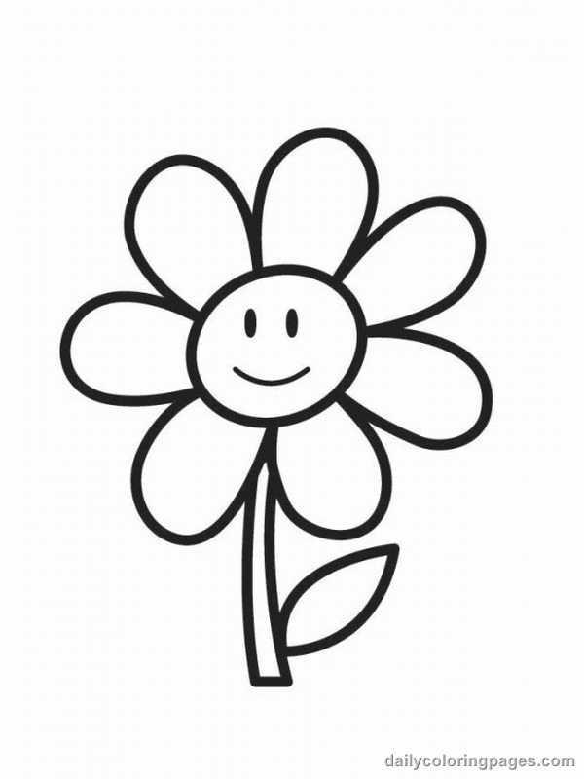

colour 6 boats

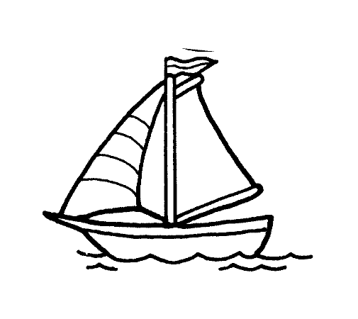

Draw 6 apples Draw 6 flowers
Write number 7
7 7 7 7 7 7 7 7
7________________
7________________
7________________
colour 7 flowers

Colour 7 butterflies

Colour 7 kites

