Mrs Lally’s 4th Class
May 25th to 29th
Maths:
- Mathemagic page 166-168. Please do all of this chapter as it’s quick and the last new topic! On page 168 make sure to read the yellow box then work from the pictures for No. 1-6.
- Brain Teasers Test 105 – 108
- F.I.O. page 48 + 49 attached to email. This is important revision. A video to help you will be posted on Google Classroom. Please send pg 48 to me via email or G.C 😊
- A few Maths Challenge tests, if possible.
English:
- A Day in the Indus Valley attached to email. Read the story and answer the questions.
- Just Grammar page 36, 39 and 41. Answers attached. A video will be posted on Google Classroom to help with page 36 and 41. Please send pg 41 to me 😊
- Spellbound Week 34 page 70 and 71 only as it’s very long.
- Handwriting – two neat pages

Gaeilge:
- Bua na Cainte léigh lth 183 voice recording / translation attached to email
- Scríobh alt ‘Lá ag Siopadóireacht’. Write a paragraph or two about a shopping trip - it can be real or imaginary. Use lth 183 to help you and all the briathra agus foclóir you have learned this year. You could start with…Lá amháin chuaigh mé ag siopadóireacht sa lárionad siopadóireachta. Bhí an áit plódaithe le daoine. Chuaigh mé isteach i Boots. Cheannaigh mé ___________. Ansin chuaigh mé isteach sa siopa spóirt agus cheannaigh mé ____________. Bhí áthas an domhain orm.
Please send this piece of writing to me via email or GC😊. Go raibh maith agaibh!
- Bun go Barr lth 26 + 27 B + C. Answers attached to email
- Sa Bhaile Mór focal cuardach (wordsearch) available on Google Classroom

Music:
Water Music by George Frederic Handel was commissioned by King George I and was first performed on the river Thames on July 17th, 1717. The musicians were in boats on the river and the King and his buddies were on the Royal Barge. The 50 musicians played this piece while being rowed up and down the river! https://www.youtube.com/watch?v=Kuw8YjSbKd4
Geography: Unit 16 Energy
- Read page 93 + 94 and do the Activities at the top of page 94 into your SESE copy.
- Sorting Renewable & Non-Renewable activity attached to email (*Biomass means plant or animal material which can be used to make energy. Examples include wood, sawdust, ethanol, biodiesel and manure – yes, cow poo!)
- Identify things in your house that need energy to work. In your copy, divide them into a list of things that use Renewable Energy and then a list of things that use Non-Renewable.

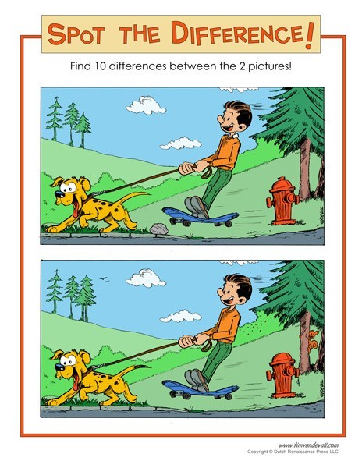
Puzzle:

Study Ladder:
Chance (Maths), Recount Reading (English) and Water (Science) activities if you have time. These activities will provide a nice challenge for you!

