Mrs. Lally’s 4th Class
June 8th to 12th

Maths: Revision
- Figure it Out Test 3 pages 94 – 96 attached and uploaded. *Please send page 96 to me for correction. Two videos will be posted on Google Classroom to help you with Time and Fractions. Please take the time to watch these videos!
- Mathemagic page 170 No. 1, 4 and 5 and page 172 No. 3 + 4. A video will be posted to help with Equivalent Fractions.
- Brain Teasers Test 113 – 116
- A few Maths Challenge tests, if possible. Let me know if you have finished the book.

Science: Recycling
- Watch the following short videos:
https://www.youtube.com/watch?v=E-pmxaiZ-NM
https://youtu.be/sZZsBedy0CU
- Read the poem ‘A Dragon in the Classroom’ on page 116 of Crazy Carnivals
- Create something out of recycled material. It could be a robot, a house, a toy, anything at all in which you are interested. *Upload a photo of your creation to the Google Classroom Stream or email it to me.

Gaeilge: An Samhradh
- Bua na Cainte lth 200 ‘An Trá’ véarsa a dó attached and uploaded
- Bua na Cainte léigh lth 197 voice / translation attached. Déan 1 – 6 agus 1 – 4 into your Gaeilge copy. Answers attached. *Send this to me for correction, please.
- Bun go Barr lth 78 (word only answers) agus lth 79 B only into your Gaeilge copy. Answers attached to email
English:
- Just Grammar page 42 + 43 (last new topic!) Answers attached to email *Send this to me, please. It’s tricky!
- Women in Science: Marie Curie attached and uploaded. Read and complete the questions.
- Handwriting – 2 neat pages to be sent to me, please*.
- Spellbound. This book should be finished. Check for any pages you may have skipped.
Puzzle:
The river crossing problem
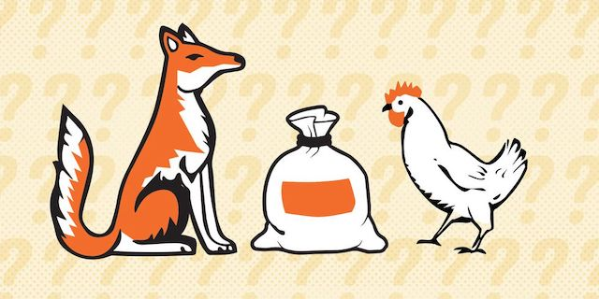
A farmer is traveling with a fox, a goose, and a bag of beans. During his journey, he comes across a river with a boat to cross it.
The farmer can only fit one thing in the boat with him at a time. If left alone together, the fox will eat the goose or the goose will eat the beans. How does the farmer get everything across the river safely?
*Private message me on Google Classroom or email your answers to me

Study Ladder:
Take a look at the new topics added: Time, Fractions, Spelling & Biography reading activity.

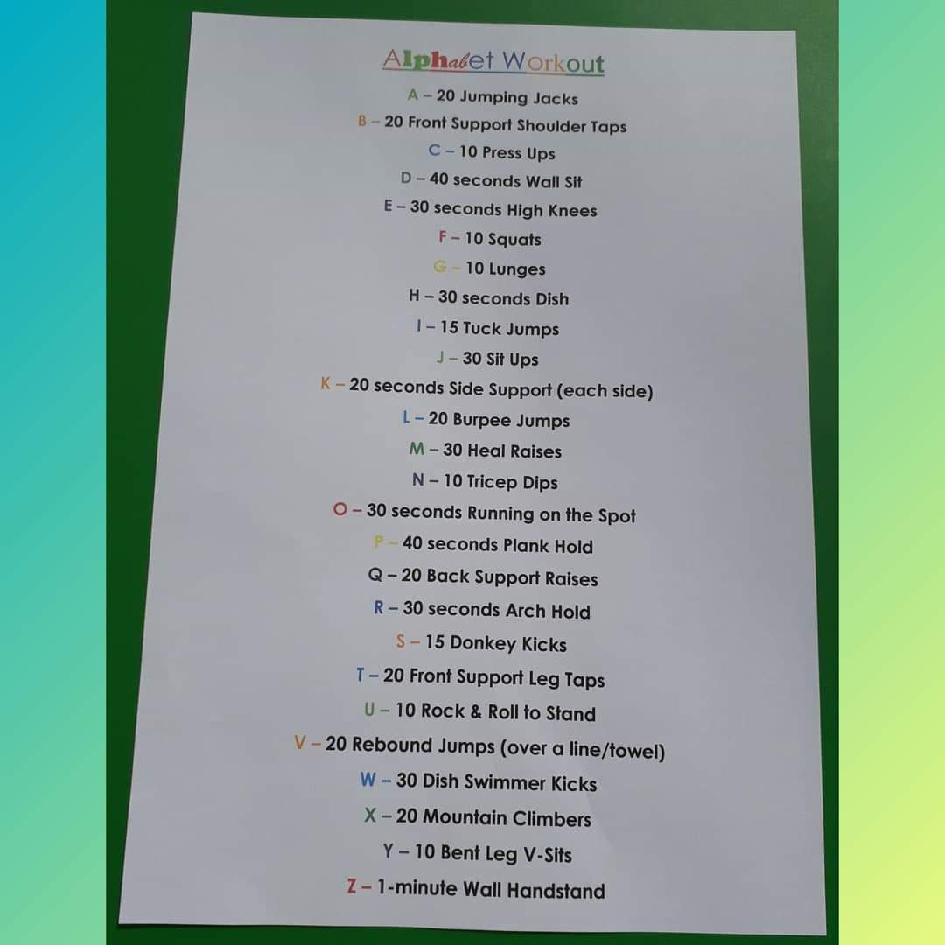
P.E: This is for all the gymnasts out there. Spell your name with these moves…

