Mrs. Lally’s 4th Class
June 15th– 19th

Maths: Revision
- Mathemagic page 174 no. 1 – 13
- Brain Teasers Test 101 – 104 (the end😊)
- 5 Maths Challenge tests

English:
- Just Grammar page 44 + 46 (the end 😊)
- A Holiday Suggestion attached to email. Read and complete the questions
- Handwriting – 2 more neat pages
- Make a list of books you will read over the summer holidays

Gaeilge: An Samhradh
- Bua na Cainte léigh lth 199 (an críoch 😊) voice / translation attached agus déan Ceist 1 – 12. Use the red boxes at the bottom to help you. Answers attached to email
- Bun go Barr lth 104 A agus 105 B (Brúigh = pressed) (Stróic = tore)

P.E: My favourite activity
- Upload a video to G.C. of you doing any sporting activity you enjoy. I already have one from Evan Ryan that I will upload to Google Classroom to get us started.

S.E.S.E: Water Safety
- Please look at the PAWS water safety programme https://watersafety.ie/wp-content/uploads/2019/10/PAWS-3-Presentation.pdf
We need to keep safe in the water over the summer holidays!
Thank you to all the mums, dads, grannies, grandads, siblings and especially you, the children of 4th Class, for working so hard to complete our programme of work for the year. It hasn’t been ideal but we have tried to make the best of things. I appreciate your effort and perseverance so very much. I have learned so many new things myself! I hope you enjoy your summer holidays and I will see you in September…..in school, I hope!!! Lots and lots of love from Mrs L xxx
Puzzle:
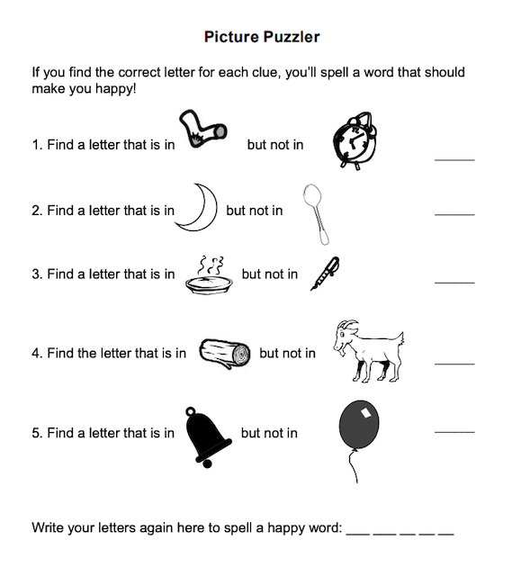
Have a wonderful summer, chickens!!

